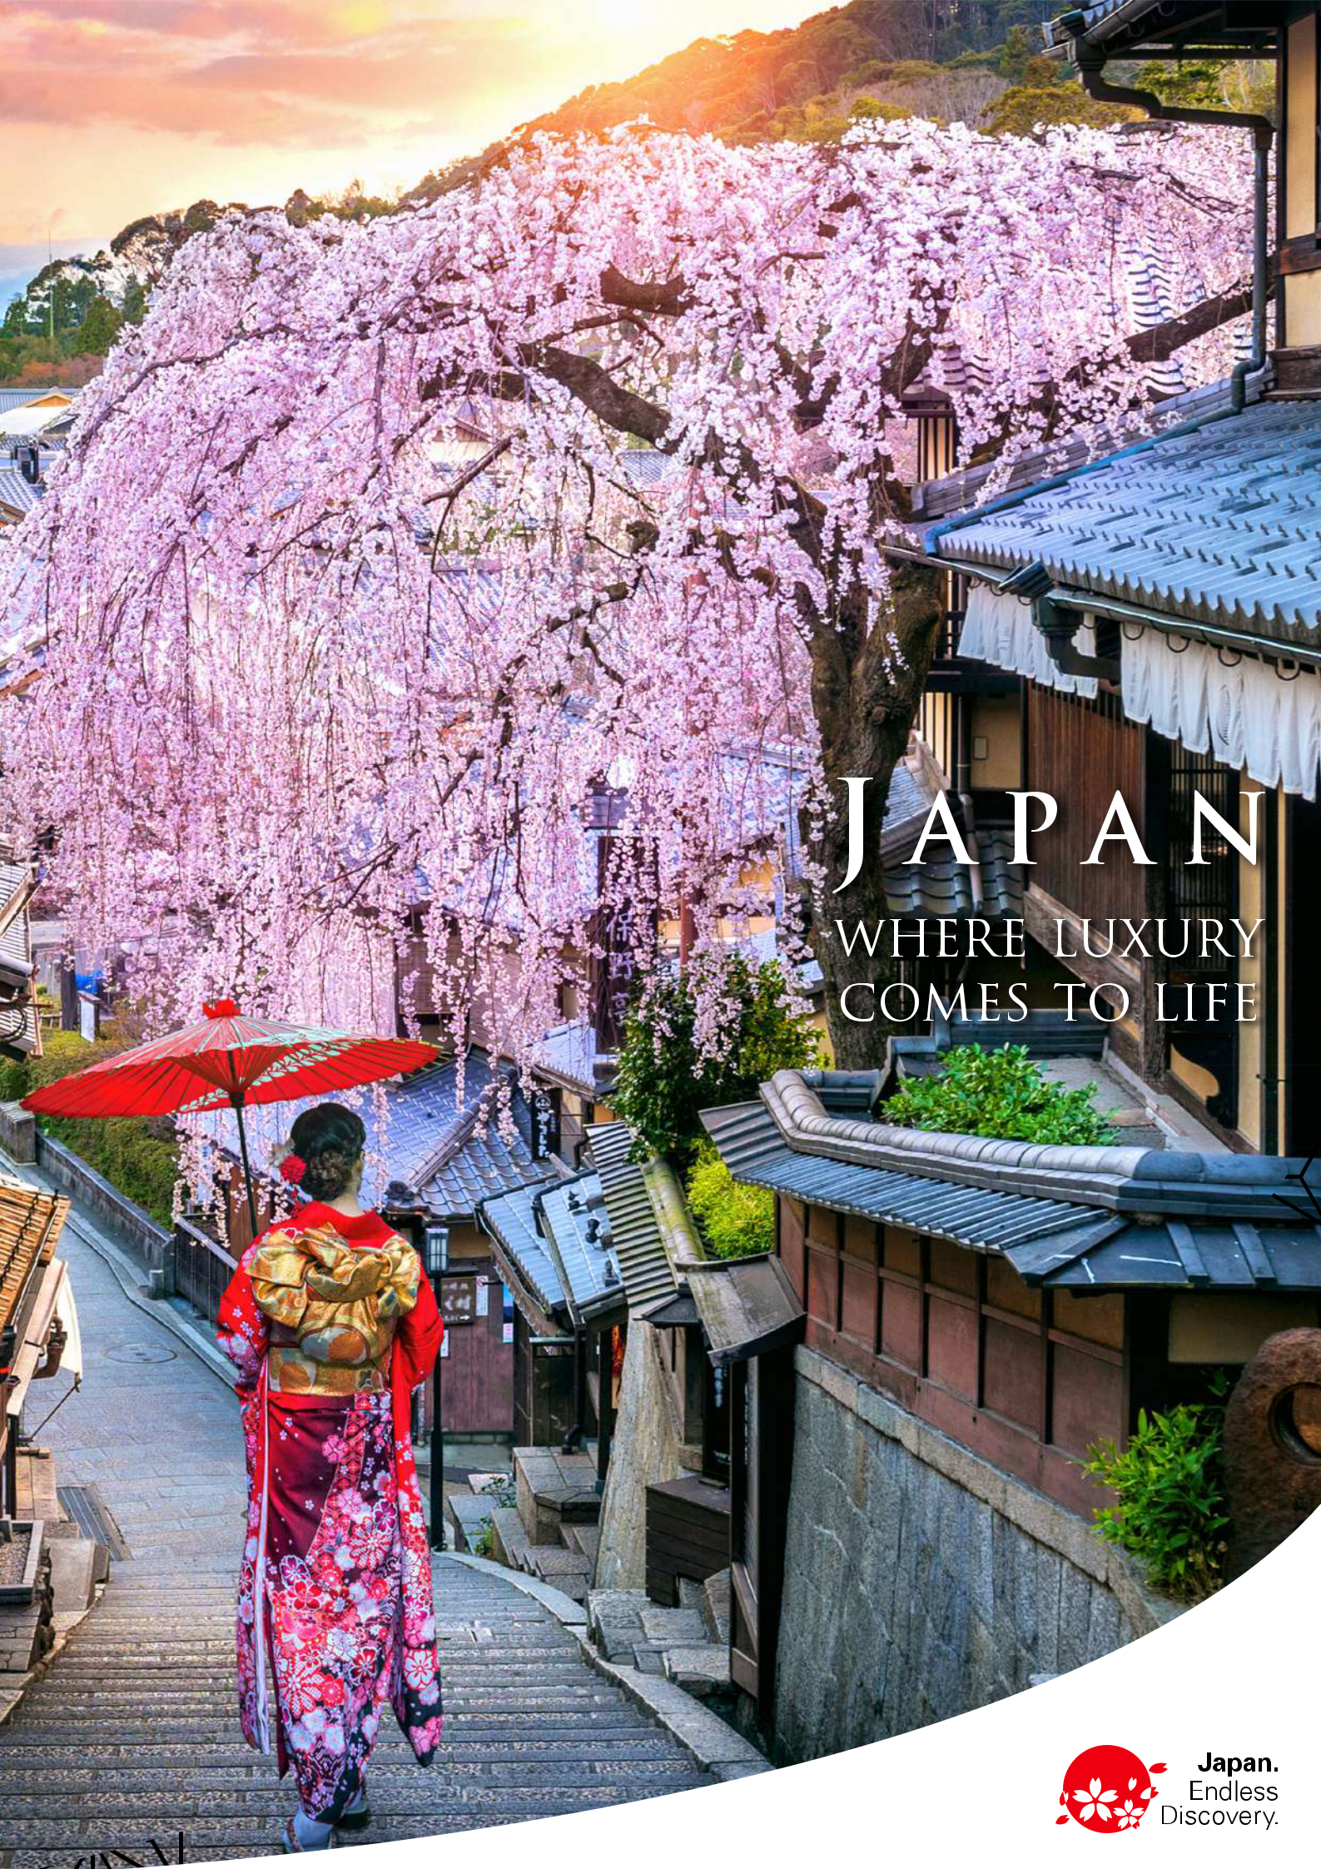

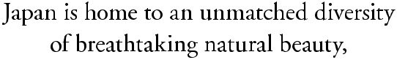

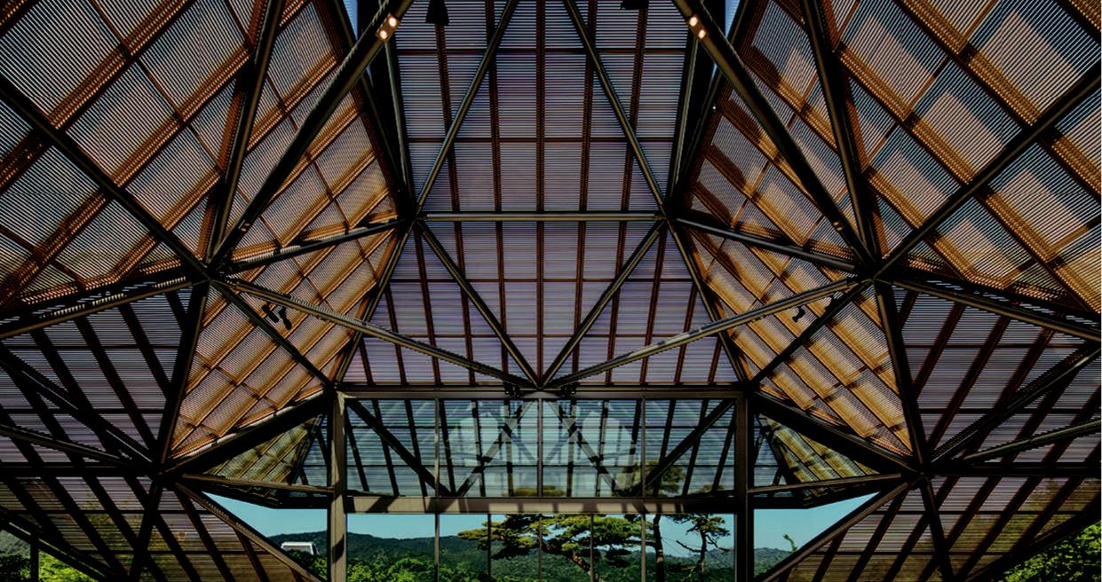

(C) MIHO MUSEUM

INTRODUCTION

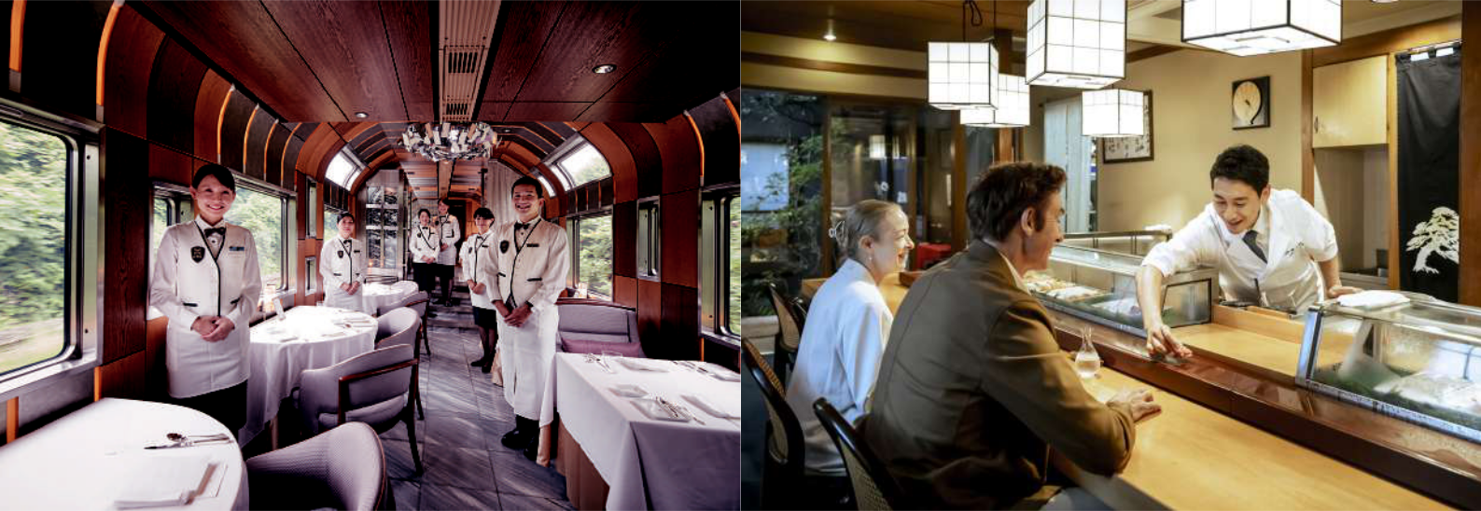

©East Japan Railway Company

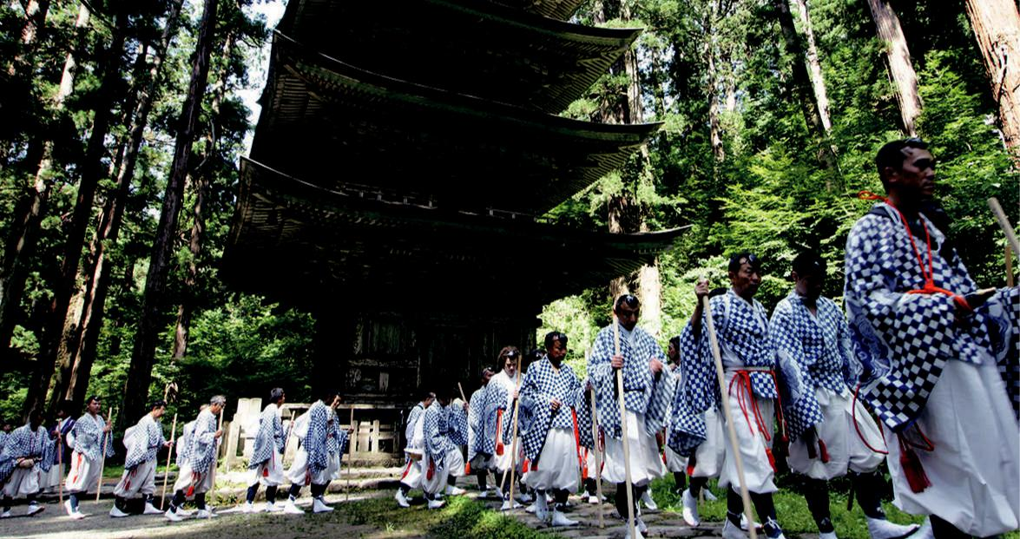

B lessed with a rich cultural heritage and resplendent nature, Japan is a captivating beauty that de-lights all the senses. Not only is it a treat for the eyes, but its dynamic culture and unique traditions also have a way of touching hearts. From snowy northern Hokkaido to tropical southern Okinawa, each of Japan’s 47 prefectures has a distinct charm, with myriad wonders waiting to be discovered.

Japan’s fascinating dualities are a testament to its emphasis on “wa” (harmony), one of the cornerstones of Japanese culture. This is a land where futuristic metropolises coexist with secluded natural paradises. In big cities like Tokyo and Osaka, towering skyscrapers stand alongside ancient temples, shrines, and gardens.

Seasonality is also a significant guiding force in Japanese culture, influencing everything from festivals to the ingredients used in kaiseki-ryori cuisine. A cycle of seasonal delights means that no matter when you visit, you’ll experience a different facet of Japan each time: cherry blossoms in spring, lush greenery and en-ergetic festivals in summer, colorful leaves and unique delicacies in autumn, and snowscapes in winter.

For refined travelers seeking the finest accommodations, attractions, cultural experiences, and epicurean treats, we present Japan: Where Luxury Comes to Life — a carefully curated guide to exploring this exqui-site country in the lap of luxury. Let our guide help you create meaningful encounters with Japan’s abun-dance of luxurious delights.

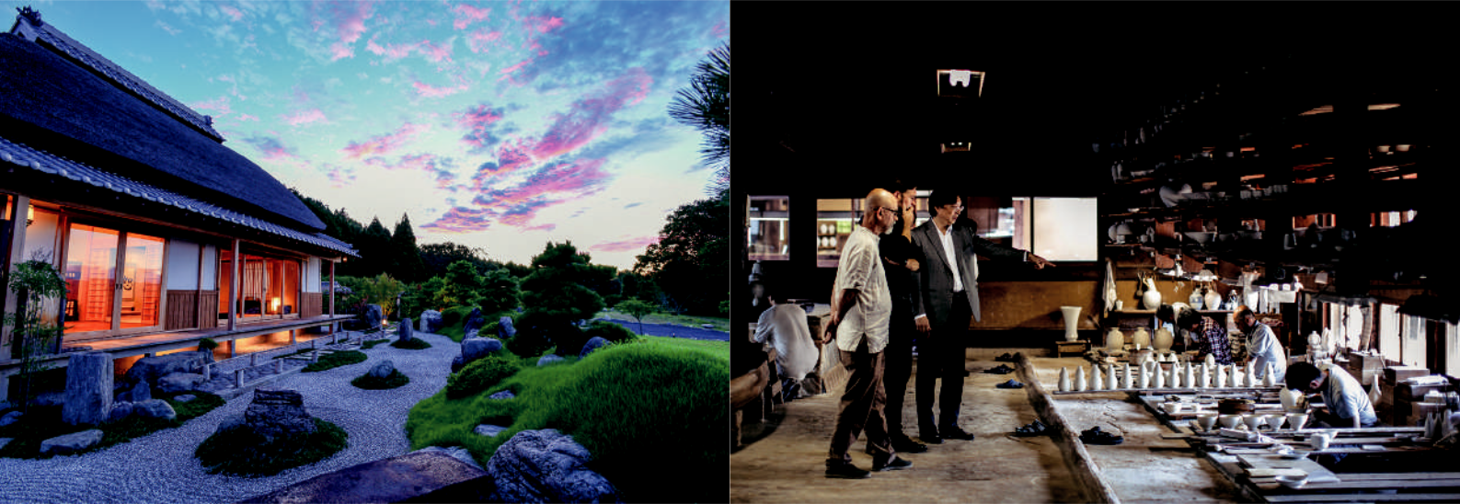

3

Chapter1 Chapter2 Chapter3 Chapter4 Chapter5 Chapter6

CONTENTS

C h a p t e r

C h a p t e r

C h a p t e r

C h a p t e r

C h a p t e r

C h a p t e r

1

2

3

4

5

6

Gastronomic Experiences



Natural Wonders



Tradition & Heritage



Arts & Culture



Traveling In Style



Luxury Accommodation



page

page

page

page

page

page

05~12

13~18

19~26

27~30

31~34

35~41

4

|  |
| --- |
| C h a p t e r |

1

AJIKITCHO HORIE

EMI NO MISE

GINZ A SUSHI AOK I

JIKI MIYAZAWA

KIKUNOI

L’EFFERVESCENCE

MATSUNOZUSHI (SUSHI MAKING EXPERI-

ENCE)

MOLIERE

NARISAWA

NORIKUR A STAR & MOON RESTAUR ANT

ORYOURI FUJII

OTOWA RESTAUR ANT

RYOTEI [CERULEAN TOWER SUKIYA]

SETSUGEKK A HANARE

SHUNPANRO

SUNTORY YAMAZAKI DISTILLERY

TERU SUSHI

TOBE AUBERGE R ESORT

URAKASUMI

UKAI CHIKUTEI

YANAGAWA TACHIBANA-TEI OHANA

Chapter 1 / Gastronomic Experiences



With time-tested techniques, balanced

flavors, seasonal ingredients, and atten-

tion to detail at its core, Japanese cuisine

is committed to perfection. When in

Japan, expect to be served the world’s

finest sashimi, melt-in-your-mouth beef,

and more. And while there’s no shortage

of outstanding options for local delica-

cies, Japan’s commitment to gastronomic

excellence also extends to international

cuisine. From fresh seafood in tanks to

ceremonial techniques, dining in Japan

can be a captivating sensory performance.

Elevate your Japanese culinary experience

with a chef who can reveal all the nuances

of Japanese cuisine on a private food tour.

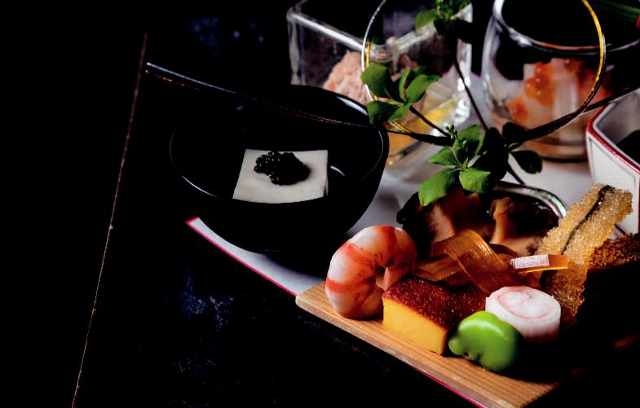

©Cerulean Tower Tokyu Hotel

Gastronomic Experiences

5

Chapter 1 / Gastronomic Experiences

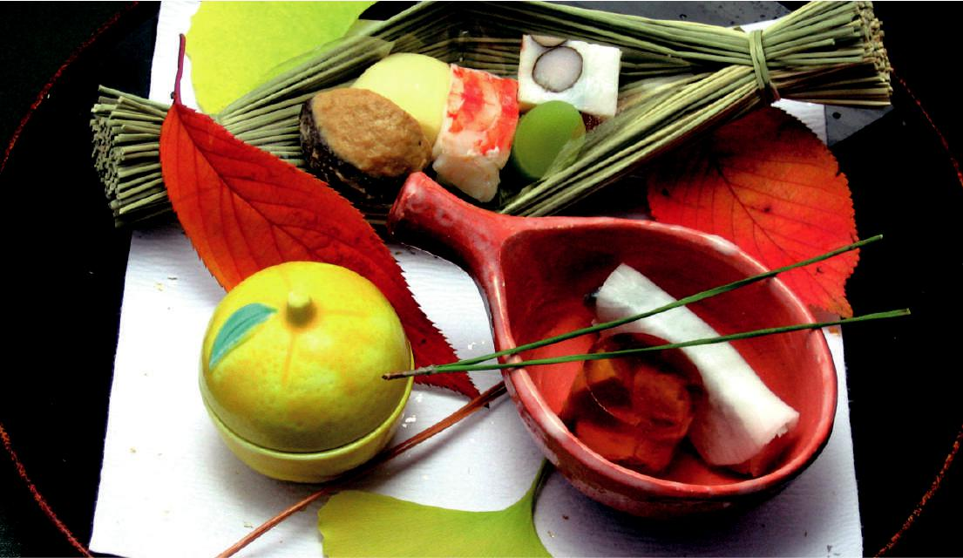

**001**

AJIKITCHO HORIE

At Ajikitcho in Osaka’s Hommachi district, Chef Ryusuke Nakatani showcases Osaka and Kyoto’s produce and seafood by reinventing traditional Naniwa (the re-gion’s former name) dishes while staying true to tradition. Seasonal, multi-course meals served in ceramic and wooden vessels evoke the mood of another time.

https://ajikitcho.jp/



Honmachi Garden City B1F, 3-6-4 Honmachi, Chuo-ku, Osaka-shi, Osaka

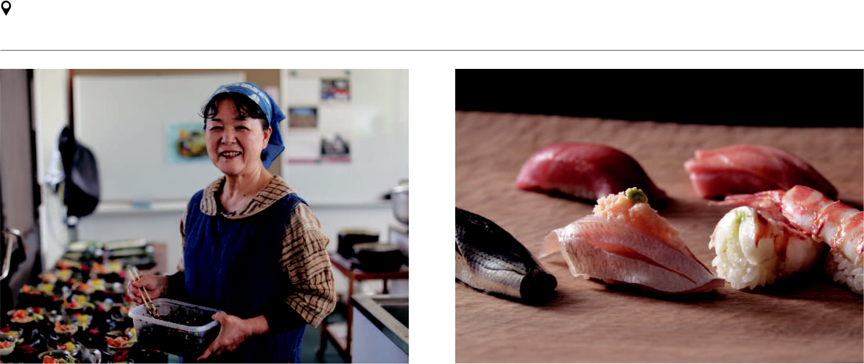

Photo by Akira Saito

**002** **003**

EMI NO MISE GINZA SUSHI AOKI

Dining like a local ensures the most authentic experience. You can do just that at Emi no Mise in Okinawa — home to Japan’s largest centenarian population. With longevity as the concept, dietitian-turned-restaurateur Emiko Kinjo metic-ulously prepares healthy meals with carefully chosen ingredients.

https://eminomise.com/en/



61 Oganeku, Ogimi-son, Kunigami-gun, Okinawa



At Ginza Sushi Aoki, watch master sushi chef Toshikatsu Aoki whip up in-credible dishes before your eyes at your own private counter. Chef Aoki not only provides the traditional sushi experience, but also improvises to create wonderful new variations. Pair your meal with champagne for further luxury.

https://www.sushiaoki.jp/en/



Ginza Takahashi Bldg. 2F, 6-7-4 Ginza, Chuo-ku, Tokyo



6

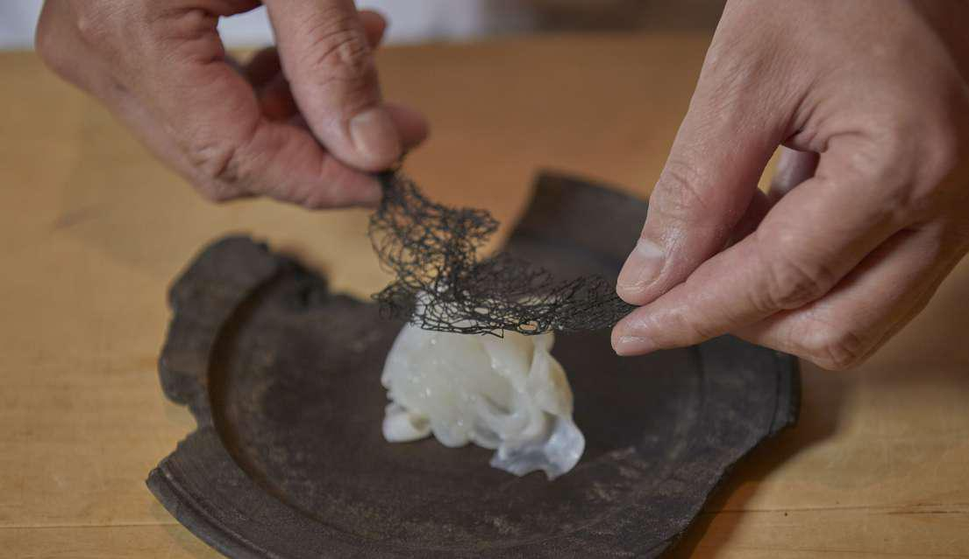

**004**

Kyoto-style kaiseki cuisine emphasizes the use of light seasonings to bring out

JIKI MIYAZAWA the natural flavors of the ingredients. This is Jiki Miyazawa’s guiding principle. Don’t be fooled by its minimalism; each dish is meticulously prepared. The shin-

ing star is yaki-gomadofu: melt-in-your-mouth tofu with salt-and-honey sauce.

https://jiki-miyazawa.com/



553-1 Yaoya-cho, Sakaimachishijoagaru Higashigawa, Nakagyo-ku, Kyo-



to-shi, Kyoto

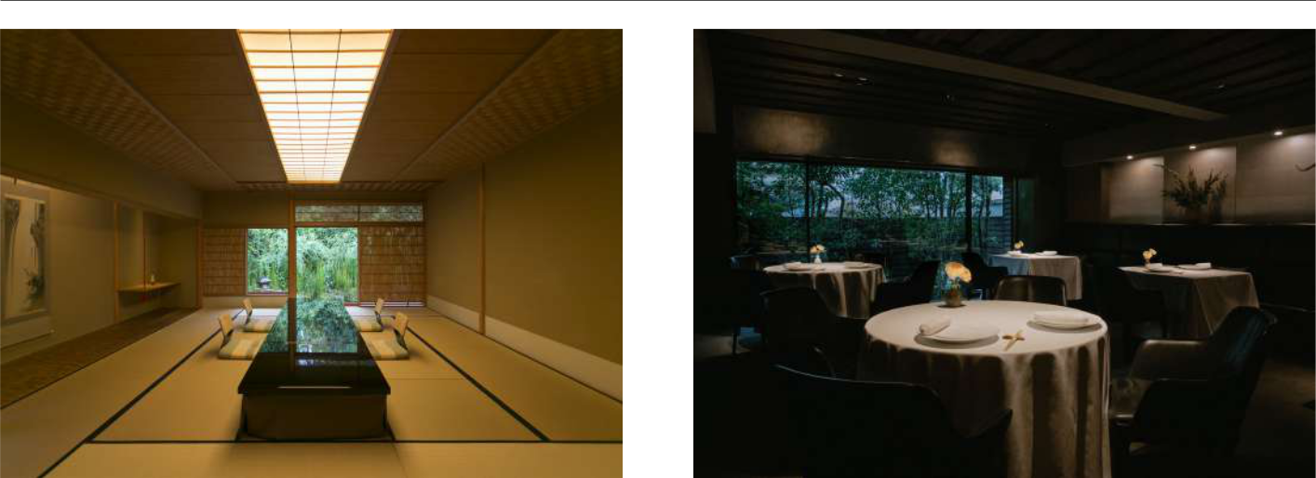

**005**

KIKUNOI

1. world-famous kaiseki-ryori restaurant, Kikunoi revolves around kirei-sabi: powerfully elegant beauty. Chef Yoshihiro Murata delights guests with exquisite seasonal dishes with harmoniously balanced flavors. Complementing the food are carefully curated tableware and decor, all with stories to tell.

https://kikunoi.jp/kikunoiweb.en/top



459 Shimokawara-cho, Yasakatoriimae-sagaru, Shimokawara-dori, Higashiyama-ku, Kyoto-shi, Kyoto



**006**

L’EFFERVESCENCE

L’Effervescence in Nishi-Azabu is one of the finest French restaurants in Tokyo. Chef Shinobu Namae serves up delights he calls “post-colonial cooking” to busy Tokyoites as part of an experience that transports diners to another reality, echo-ing the forests and oceans from which he sources the finest ingredients.

http://www.leffervescence.jp/en/



2-26-4 Nishi azabu, Minato-ku Tokyo



7

Chapter 1 / Gastronomic Experiences

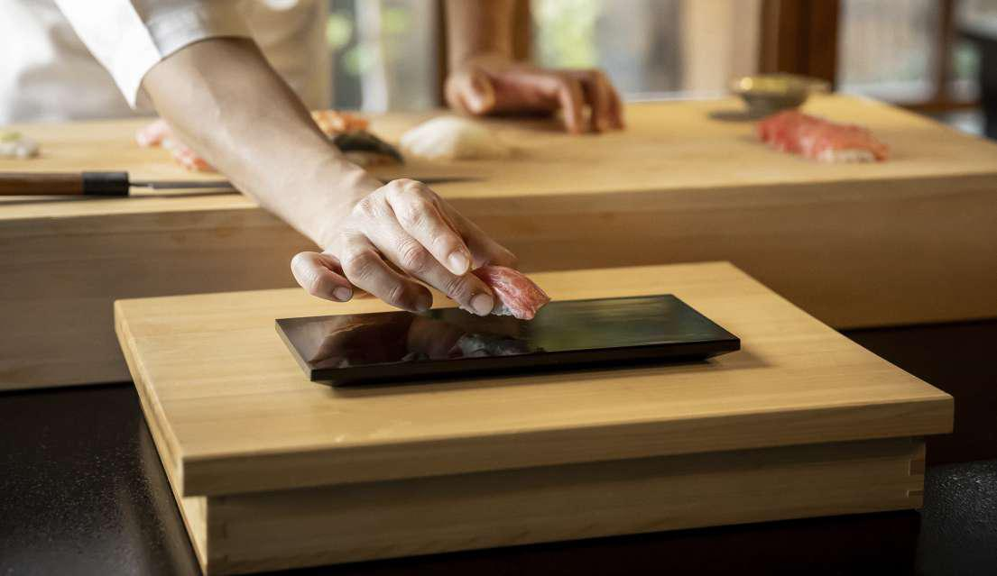

**007**

|  |  |  |
| --- | --- | --- |
| MATSUNOZUSHI | Currently led by Chef Yoshi Tezuka, a sushi ambassador who has served royalty, |  |
| Matsunozushi has specialized in Edomae sushi (sushi made with fresh seafood |  |
| (SUSHI MAKING EXPERIENCE) | from Tokyo Bay) since 1910. Learn the art of sushi-making in a private workshop, |  |
| then sit down to a meal with dishes selected and prepared by Chef Yoshi himself. |  |
|  |  |
|  |  |  |
| https://matsunozushi.com/en/ |  |  |
| 3-31-14 Minamiooi Shinagawa-ku Tokyo |  |  |
|  |  |  |

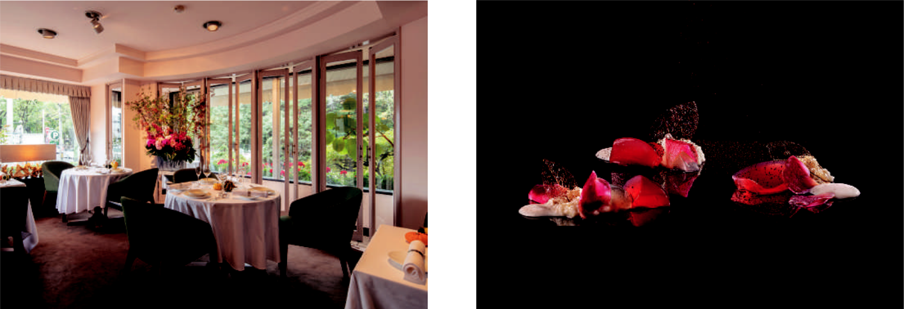

**008** **009**

MOLIERE NARISAWA

Overlooking Sapporo’s Maruyama Park, the elegant but minimalist Moliere highlights Hokkaido’s bounty: Tokachi beef, forest mushrooms, locally sourced vegetables, and seafood from nearby waters. Dishes showcase the wealth of Japa-nese cuisine, and staff spare no effort to give guests VIP treatment.

https://sapporo-moliere.com/



Lafayette Miyagaoka Bldg. 1F, 2-1-1 Miyagaoka, Chuo-ku, Sapporo-shi, Hokkaido



Based on rural Japan’s symbiotic relationship with nature, Chef Yoshihiro Nari-sawa of the Michelin-starred Narisawa has created a revolutionary cuisine called “innovative satoyama.” The menu changes daily to honor the changing seasons and Japan’s diverse landscapes, making use of specialties from across the nation.

https://www.narisawa-yoshihiro-en.com/



2-6-15 Minami Aoyama, Minato-ku, Tokyo



8

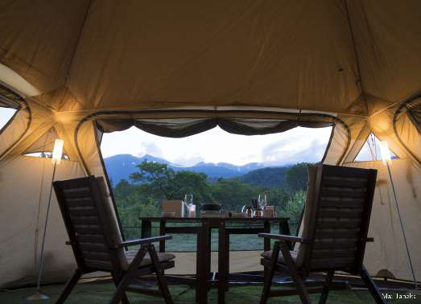

**010**

NORIKURA STAR &

MOON RESTAURANT

Glamping and Japanese cuisine come together at Norikura Star and Moon Restau-rant in Shinshu (modern-day Nagano). Deep in the Japanese Alps, guests will feast on a multi-course dinner planned by one of Tokyo’s top chefs, Chisako Hori. Enjoy Shinshu’s best cuisine, including wagyu beef and soba — plus wine and craft beer.

http://shinshu.miraidukuri.jp/en/ 122-1 Azumi Oonota, Matsumoto-shi, Nagano

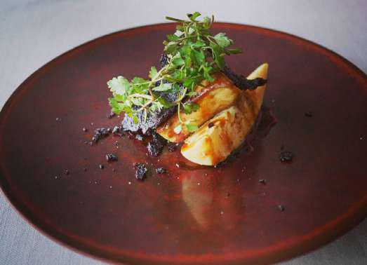

**012**

OTOWA RESTAURANT

Helmed by Chef Kazunori Otowa, Otowa Restaurant presents French cui-sine that reflects Japan’s four seasons and the chef’s devotion to Tochigi. Using high-quality ingredients sourced mostly from local farms, Chef Otowa trans-forms even classic local produce into beautiful, exciting dishes.

https://otowa-artisan.co.jp/ 3554-7 Nishihara-cho, Utsunomiya-shi, Tochigi



**011**

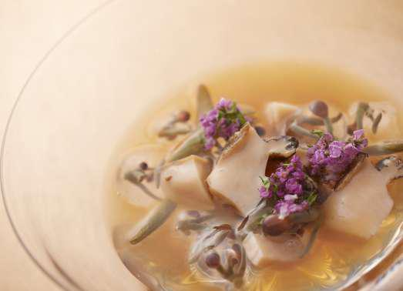

ORYOURI FUJII

Chef Hironori Fujii leverages Toyama’s delicious bounties for his restaurant Oryouri Fujii, using farm-direct ingredients procured almost exclusively from the region. Through seasonal ingredients complemented by his carefully pre-pared dashi soup stock, enjoy a taste of Japan’s four seasons.

https://www.oryouri-fujii.jp/



93 Higashiiwase-cho, Toyama-shi, Toyama

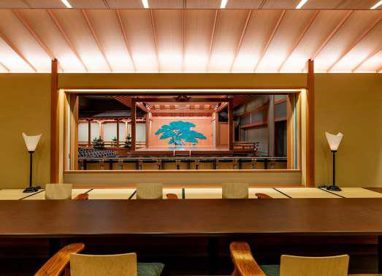

©Cerulean Tower Tokyu Hotel

**013**

RYOTEI

[CERULEAN TOWER SUKIYA]

The elegant ryotei restaurant at Cerulean Tower Tokyu Hotel offers immersive traditional dining, in an intimate setting with an authentic tearoom design. The focus on seasonality and elegant presentation is taken to new levels by Nobuhiko Fukuda, a leading light of Japan’s culinary world.

https://www.tokyuhotelsjapan.com/global/cerulean-h/ restaurant/sukiya/index.html 26-1 Sakuragaoka-cho, Shibuya-ku, Tokyo



9

Chapter 1 / Gastronomic Experiences

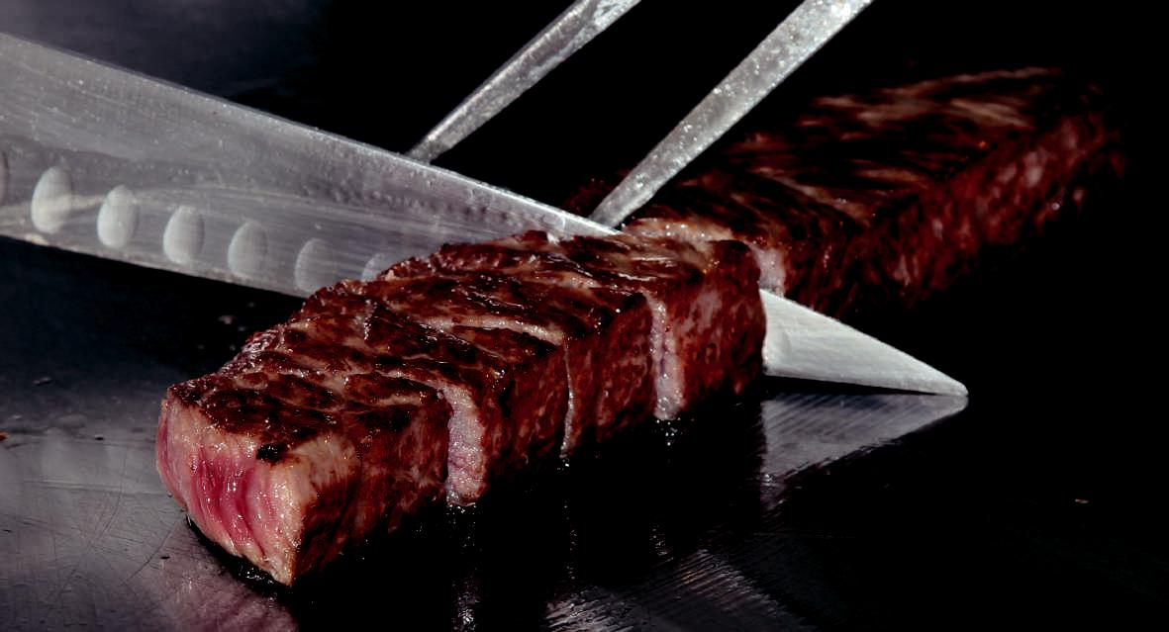

Setsugekka Hanare

**014**

SETSUGEKKA HANARE

For a refreshing change from sushi and seafood, dine at Setsugekka Hanare,

1. relaxed teppanyaki restaurant where melt-in-your-mouth premium beef takes center stage. With dishes carefully prepared in front of you, expect an out-of-this-world experience savoring the world’s highest-grade Kobe beef.

https://kobe-setsugetsuka.com/hanare



La Doll Ray Kobe Sannomiya Bldg. 8F, 1-25-6 Nakayamatedori, Chuo-ku, Kobe-shi, Hyogo

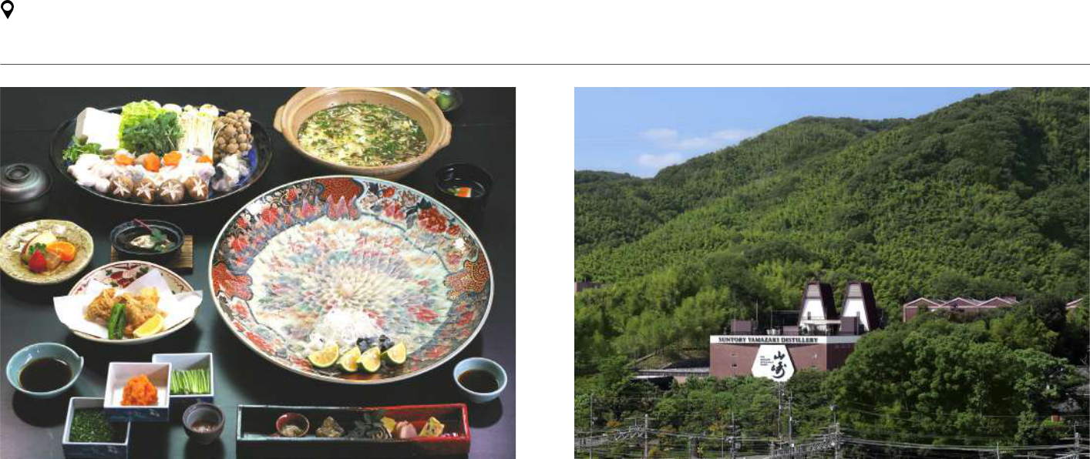

**015** **016**

SHUNPANRO SUNTORY YAMAZAKI DISTILLERY

The first restaurant publicly licensed to serve fugu (blowfish), Shunpanro has been masterfully preparing this infamous delicacy since 1888. Ito Hirobumi, Japan’s first Prime Minister, was instrumental in Shunpanro’s popularity; today, you can still expect royal treatment sampling this iconic dish.

https://www.shunpanro.com/en/ 4-2 Amidaiji-cho, Shimonoseki-shi, Yamaguchi



Visit Suntory Yamazaki Distillery to explore the oldest malt whiskey distillery in Japan and see how its acclaimed whiskey is made. You can delve into the histo-ry of Japanese whiskey at the adjacent Yamazaki Whiskey Museum (reservations required).

http://www.suntory.com/factory/yamazaki/ 5-2-1 Yamazaki, Shimamoto-cho, Mishima-gun, Osaka



10

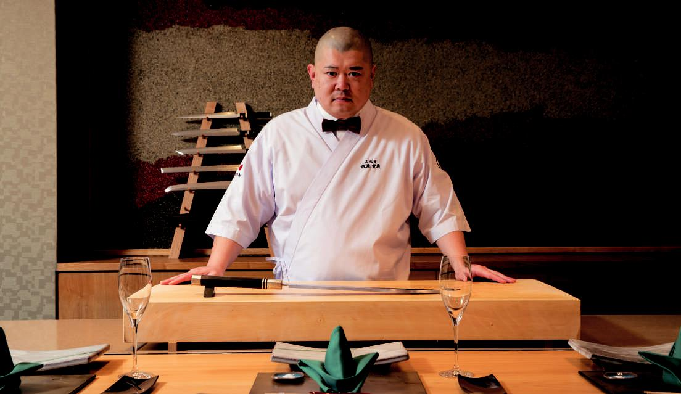

**017**

Teru Sushi pays homage to Fukuoka’s sushi traditions by selecting fish from

TERU SUSHI trusted fishermen and treating ingredients with respect. Chefs demonstrate im-pressive knife skills at the counter as they serve the best catches of the season, freshly sourced from the nearby waters of southwestern Kyushu and Yamaguchi.

https://terusushi.jp/index_english.html



3-1-7 Sugawara, Tobata-ku, Kitakyushu-shi, Fukuoka

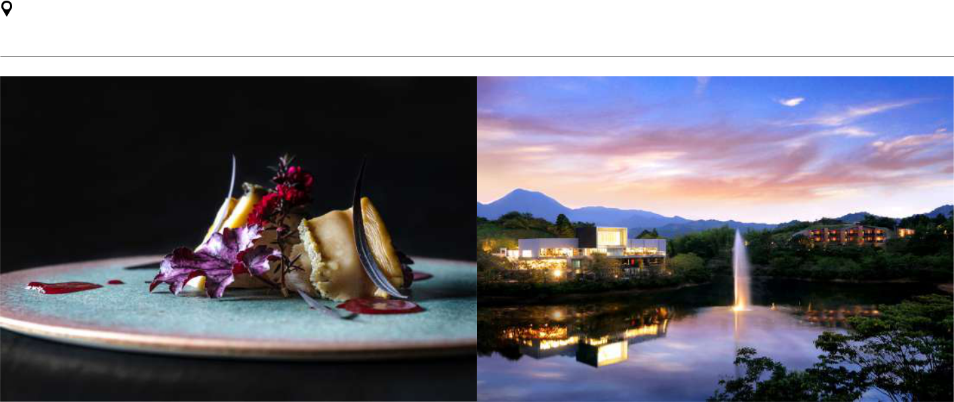

**018**

TOBE AUBERGE RESORT

Tobe Auberge Resort combines Japanese culinary spirit with the best of West-

ern techniques. Look forward to a tantalizing menu that draws on traditions

from all over the world. Tobe’s menu changes roughly every two weeks to ensure

that every ingredient reaches your plate at its best.

 http://www.tobe-resort.com/

 1622-7 Miyauchi, Tobe-cho, Iyo-gun, Ehime

11

Chapter 1 / Gastronomic Experiences

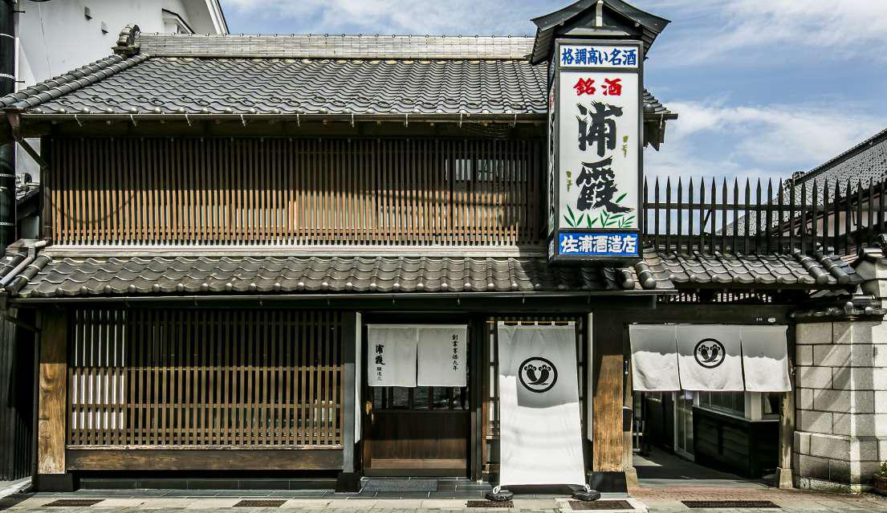

(C)URAKASUMI Saura Co., Ltd.

**019**

URAKASUMI

Based in the fishing town of Shiogama, the Urakasumi Sake Brewery has rev-olutionized sake culture since its inception in 1724. Legendary among connois-seurs, and brewed with local rice and in-house yeast, Urakasumi is one of Japan’s finest sake brands. It’s best paired with Shiogama’s fresh seafood.

https://www.urakasumi.com/en/



2-19 Motomachi, Shiogama-shi, Miyagi

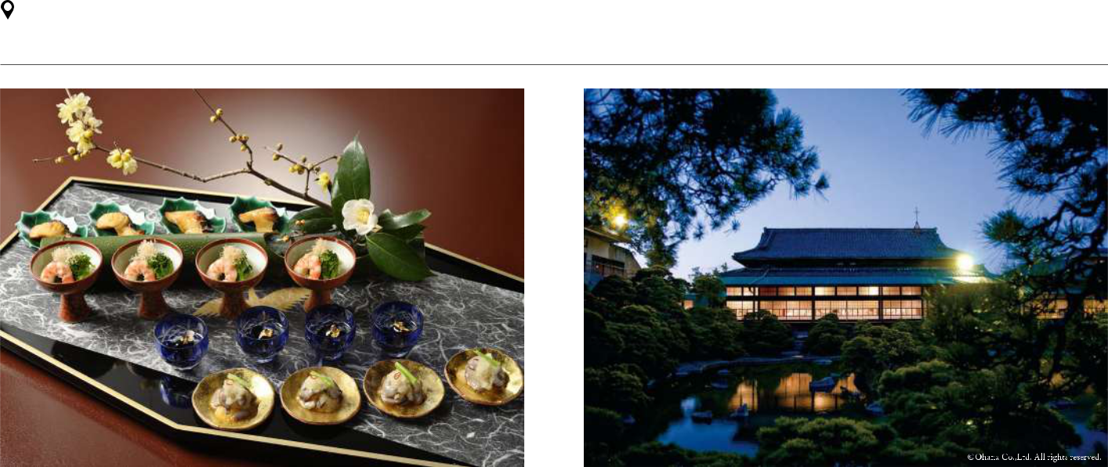

UKAI CHIKUTEI

**020** **021**

UKAI CHIKUTEI YANAGAWA TACHIBANA-TEI OHANA

At the foot of Tokyo’s Mt. Takao is Ukai Chikutei, a secluded kaiseki-ryori restaurant that overlooks a gorgeous garden. Rich and flavorful, the menu high-lights the season’s bounties: bamboo shoots in spring, sweetfish in summer, mat-sutake mushrooms in autumn, and yellowtail and crab in winter.

https://www.ukai.co.jp/english/chikutei/



2850 Minami-asakawa-machi. Hachioji-shi, Tokyo



Set in an ancient aristocratic villa, Ohana offers a dining experience overflow-ing with history and traditional culture. Enjoy an ever-changing seasonal menu in a private room with views of the gorgeous Matsuboen Garden, or taste local specialties in a more relaxed restaurant setting.

s-yoyaku@ohana.co.jp



1 Shinhokamachi, Yanagawa-shi, Fukuoka



12

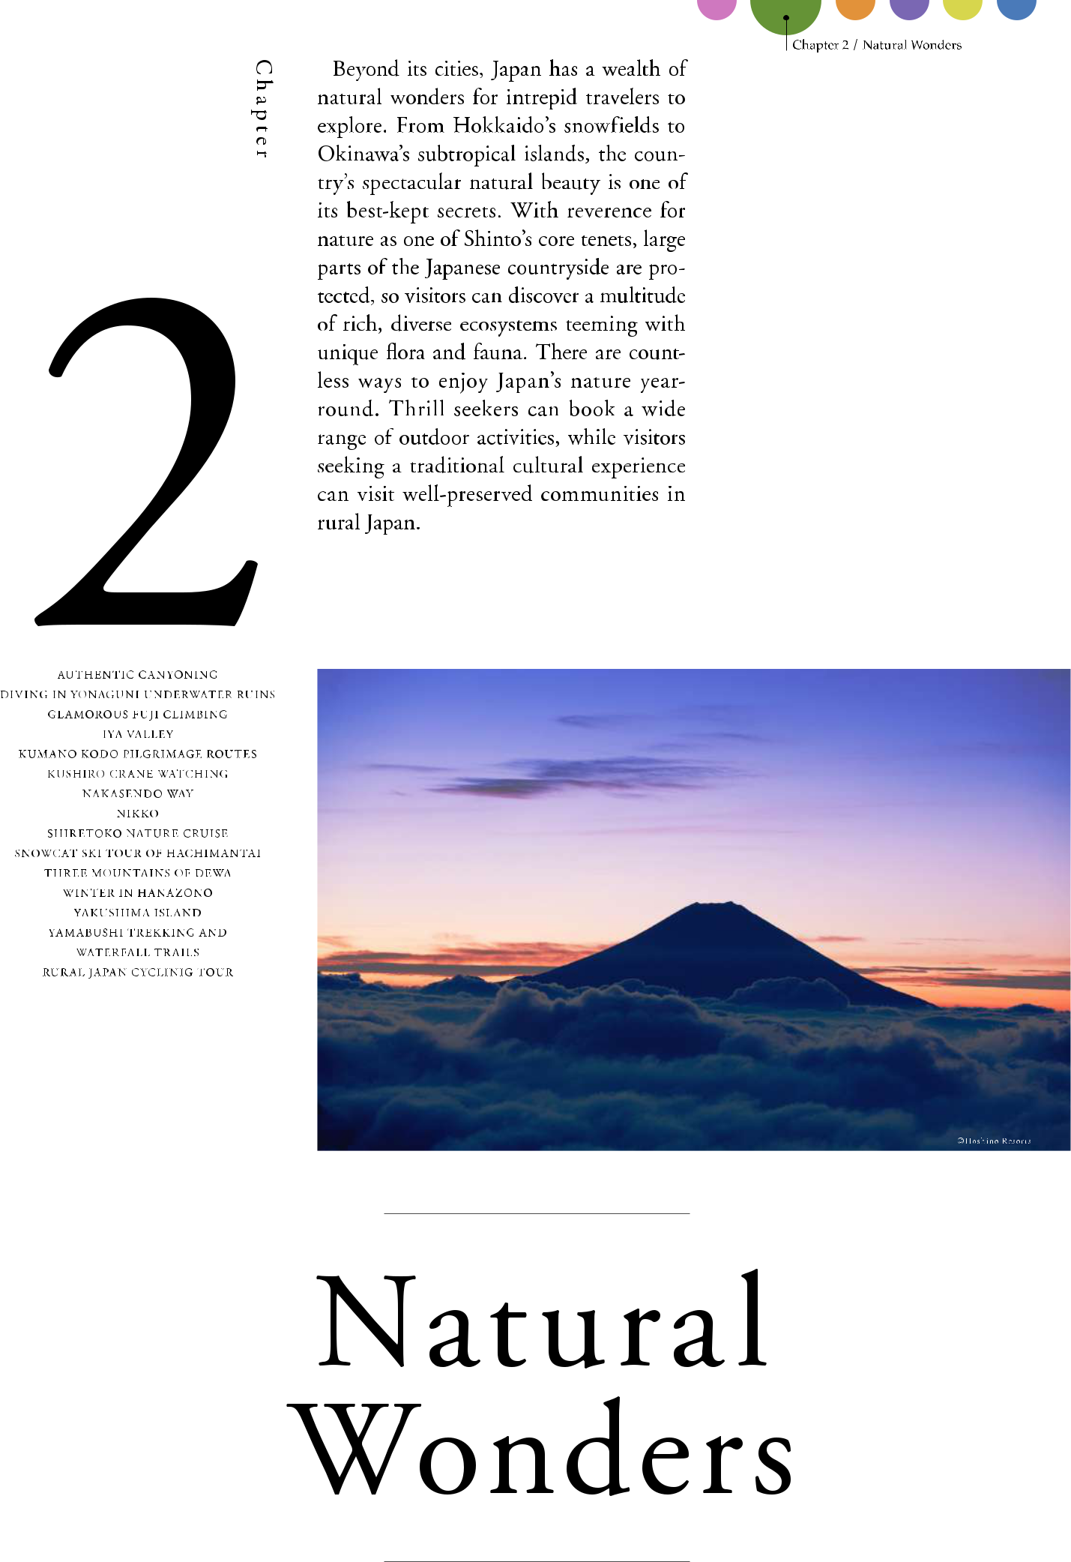

13

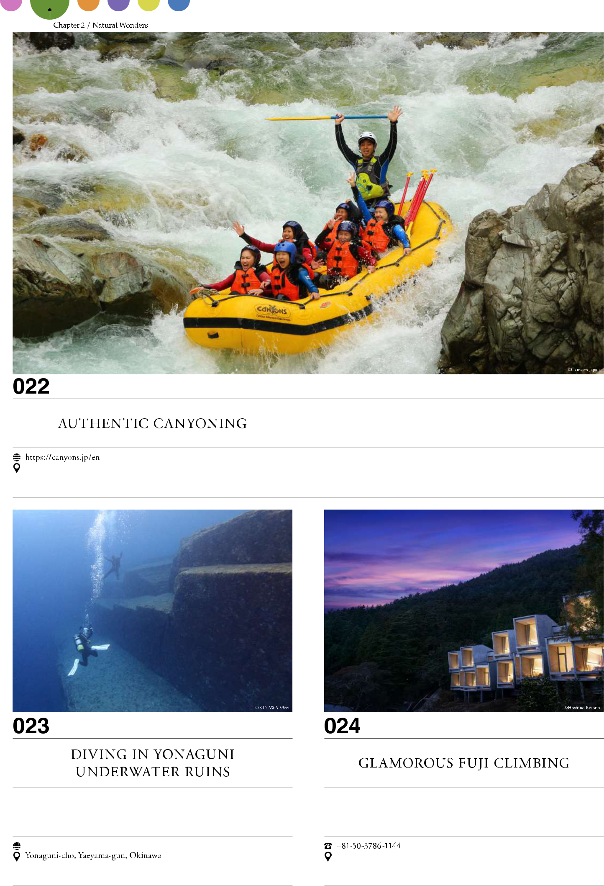

14

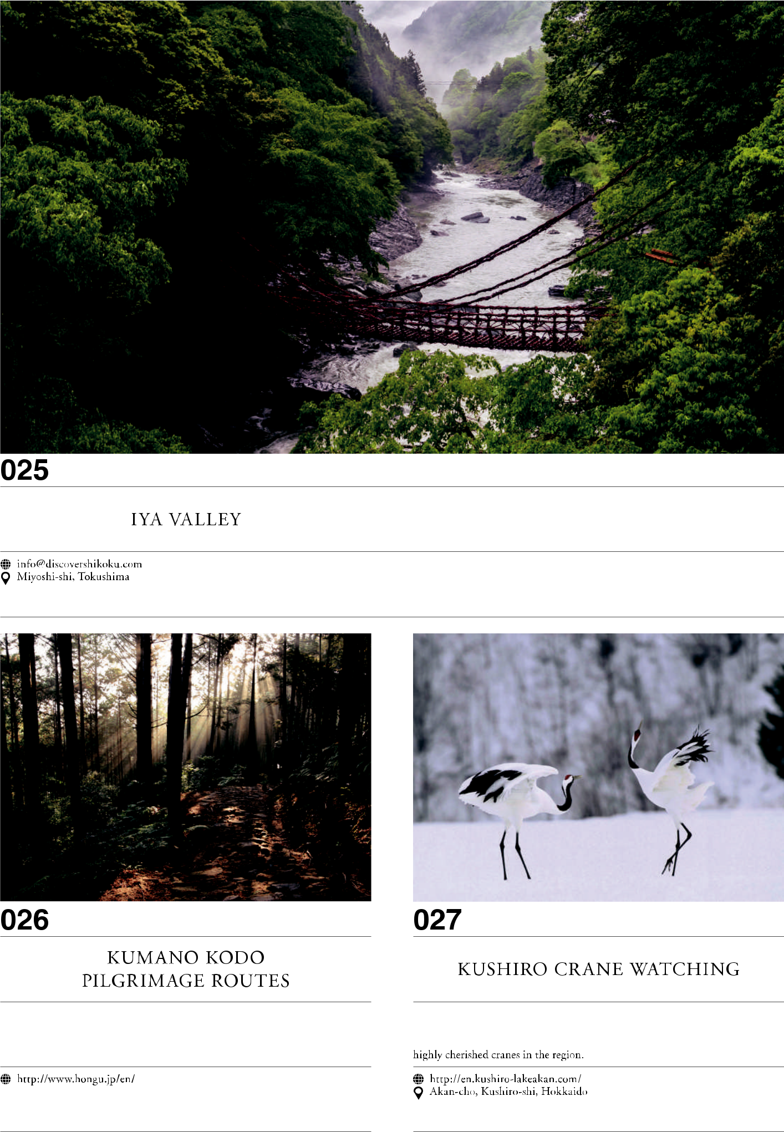

15

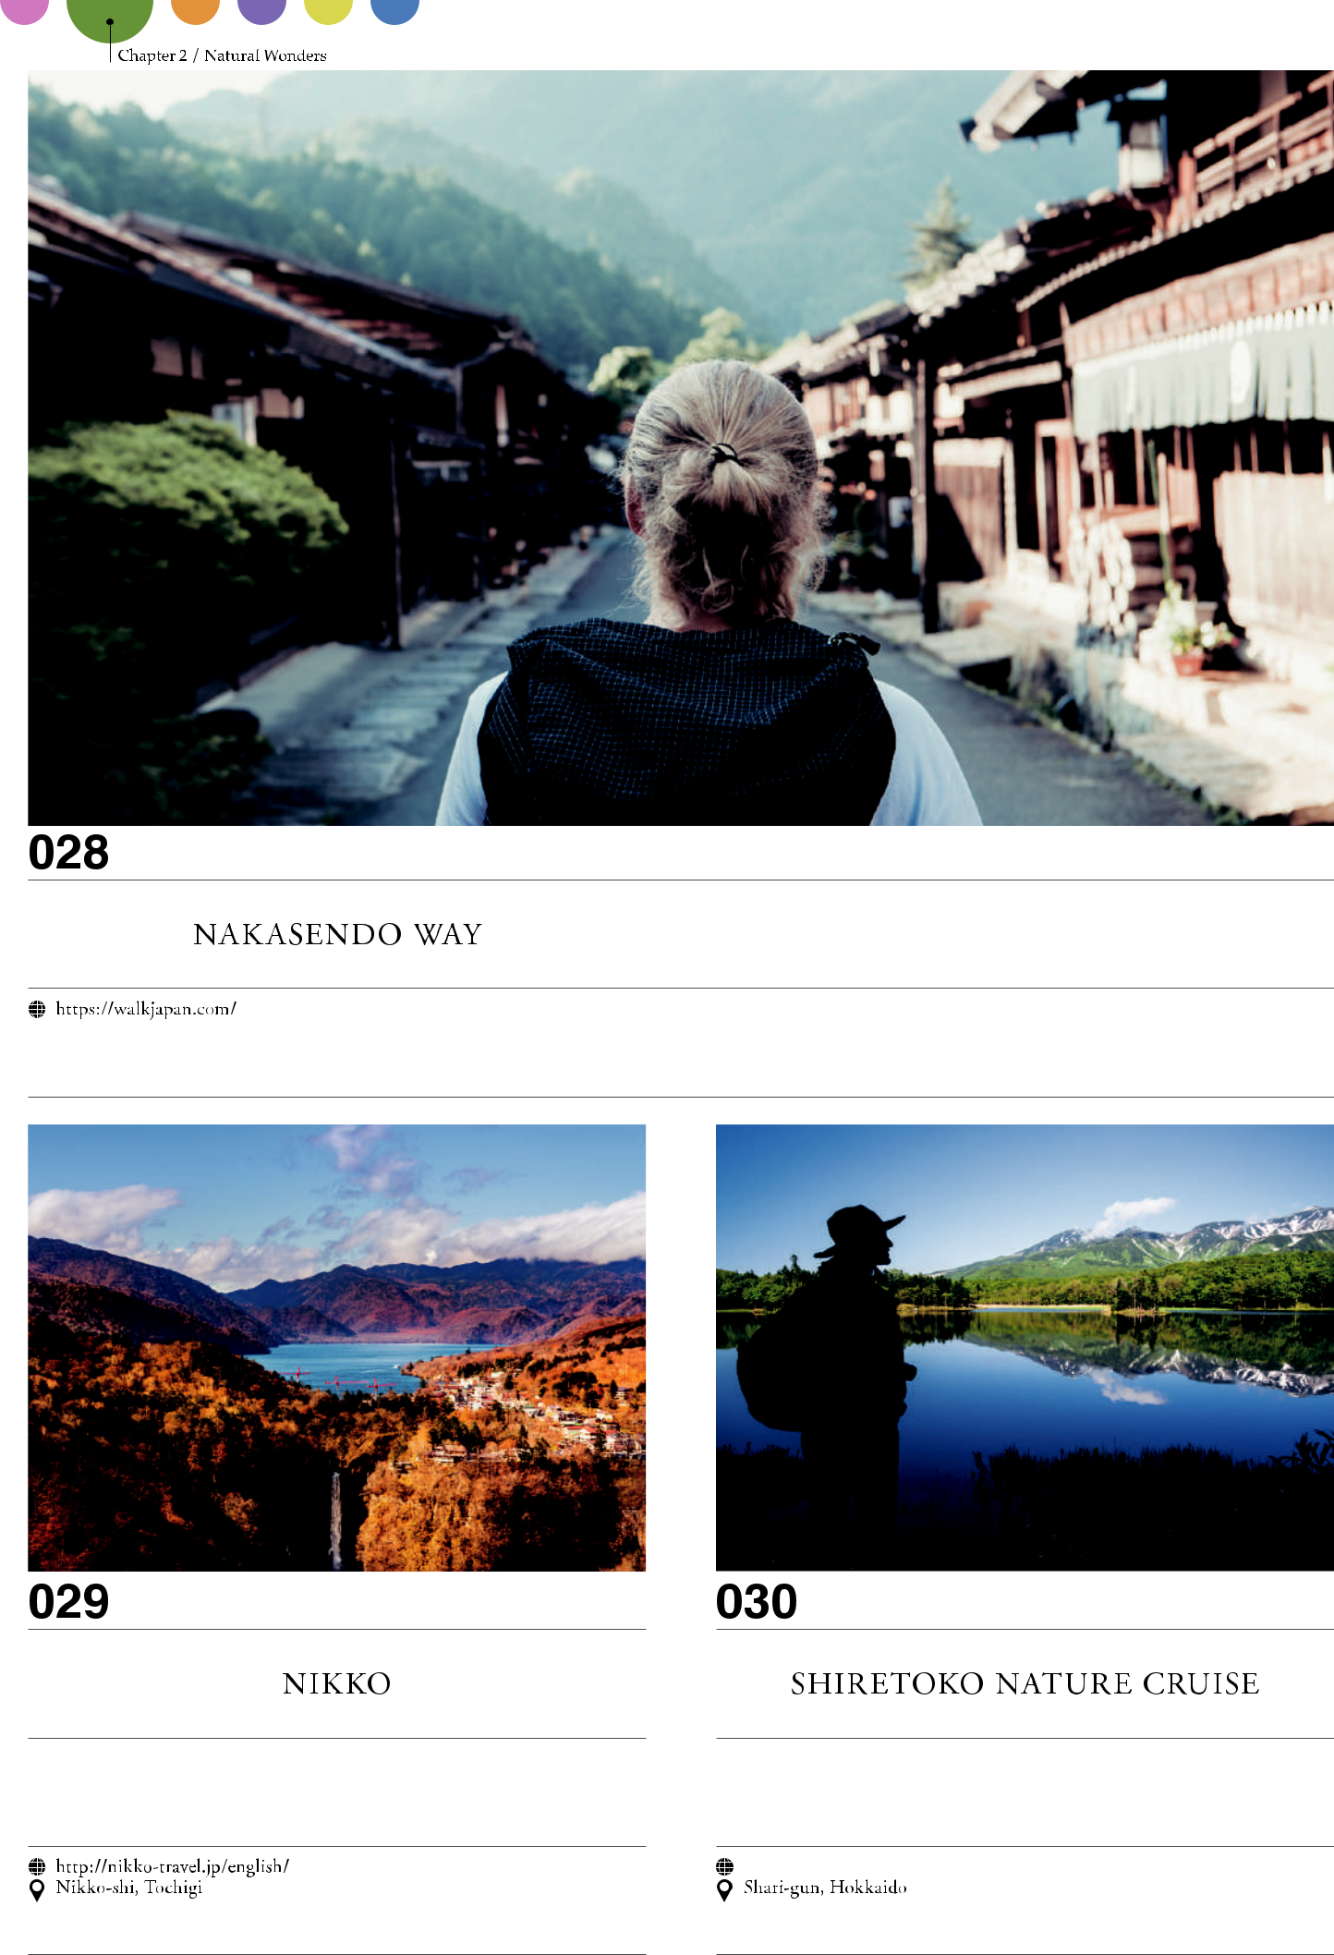

16

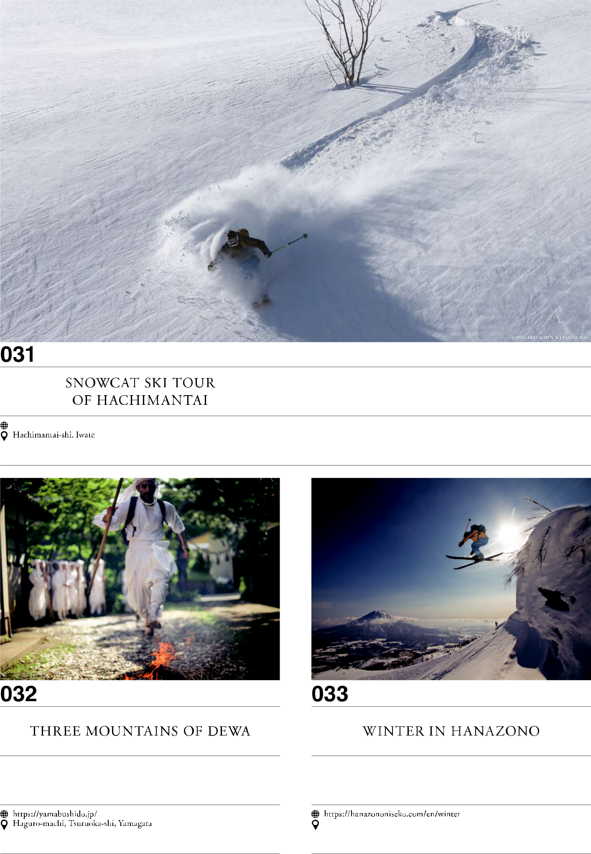

17

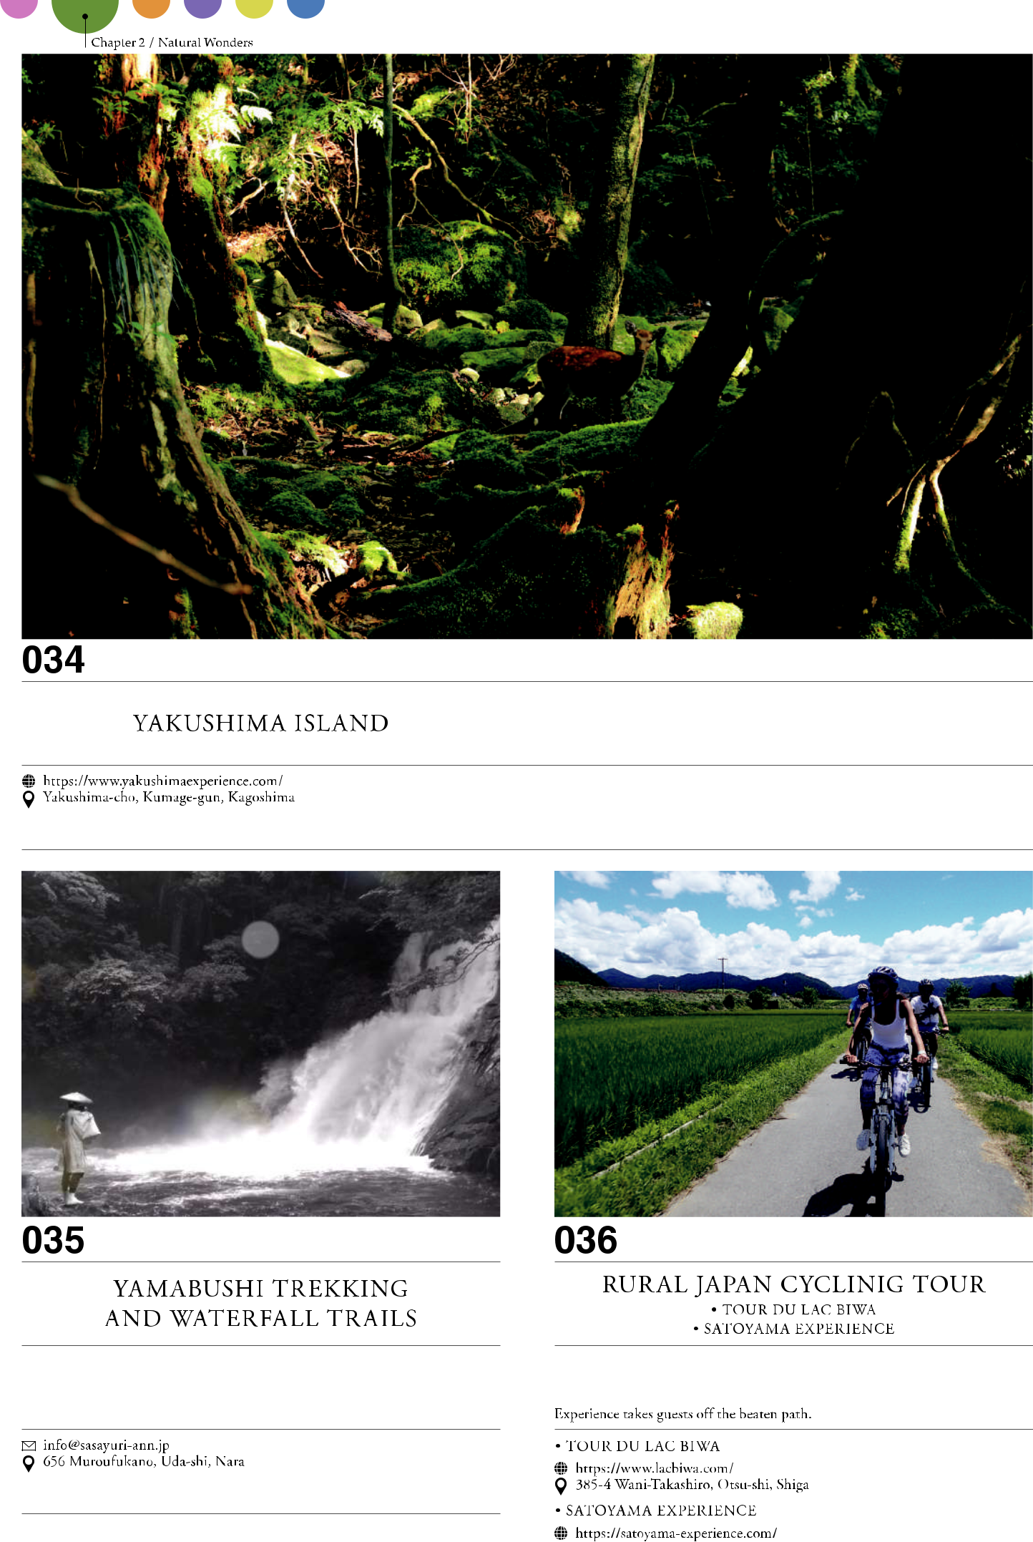

18



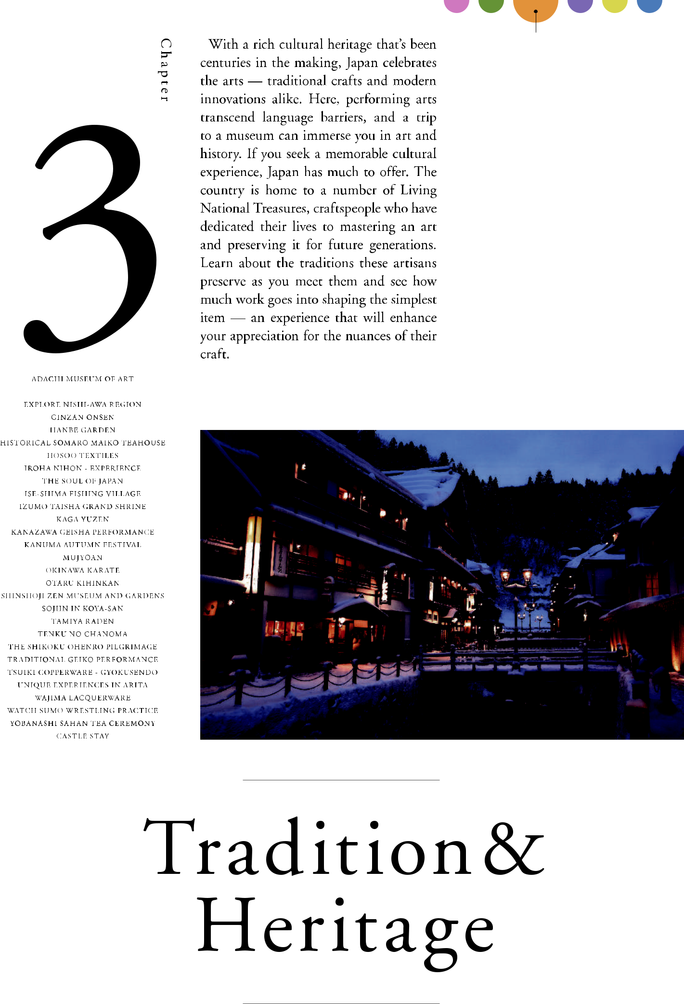

19

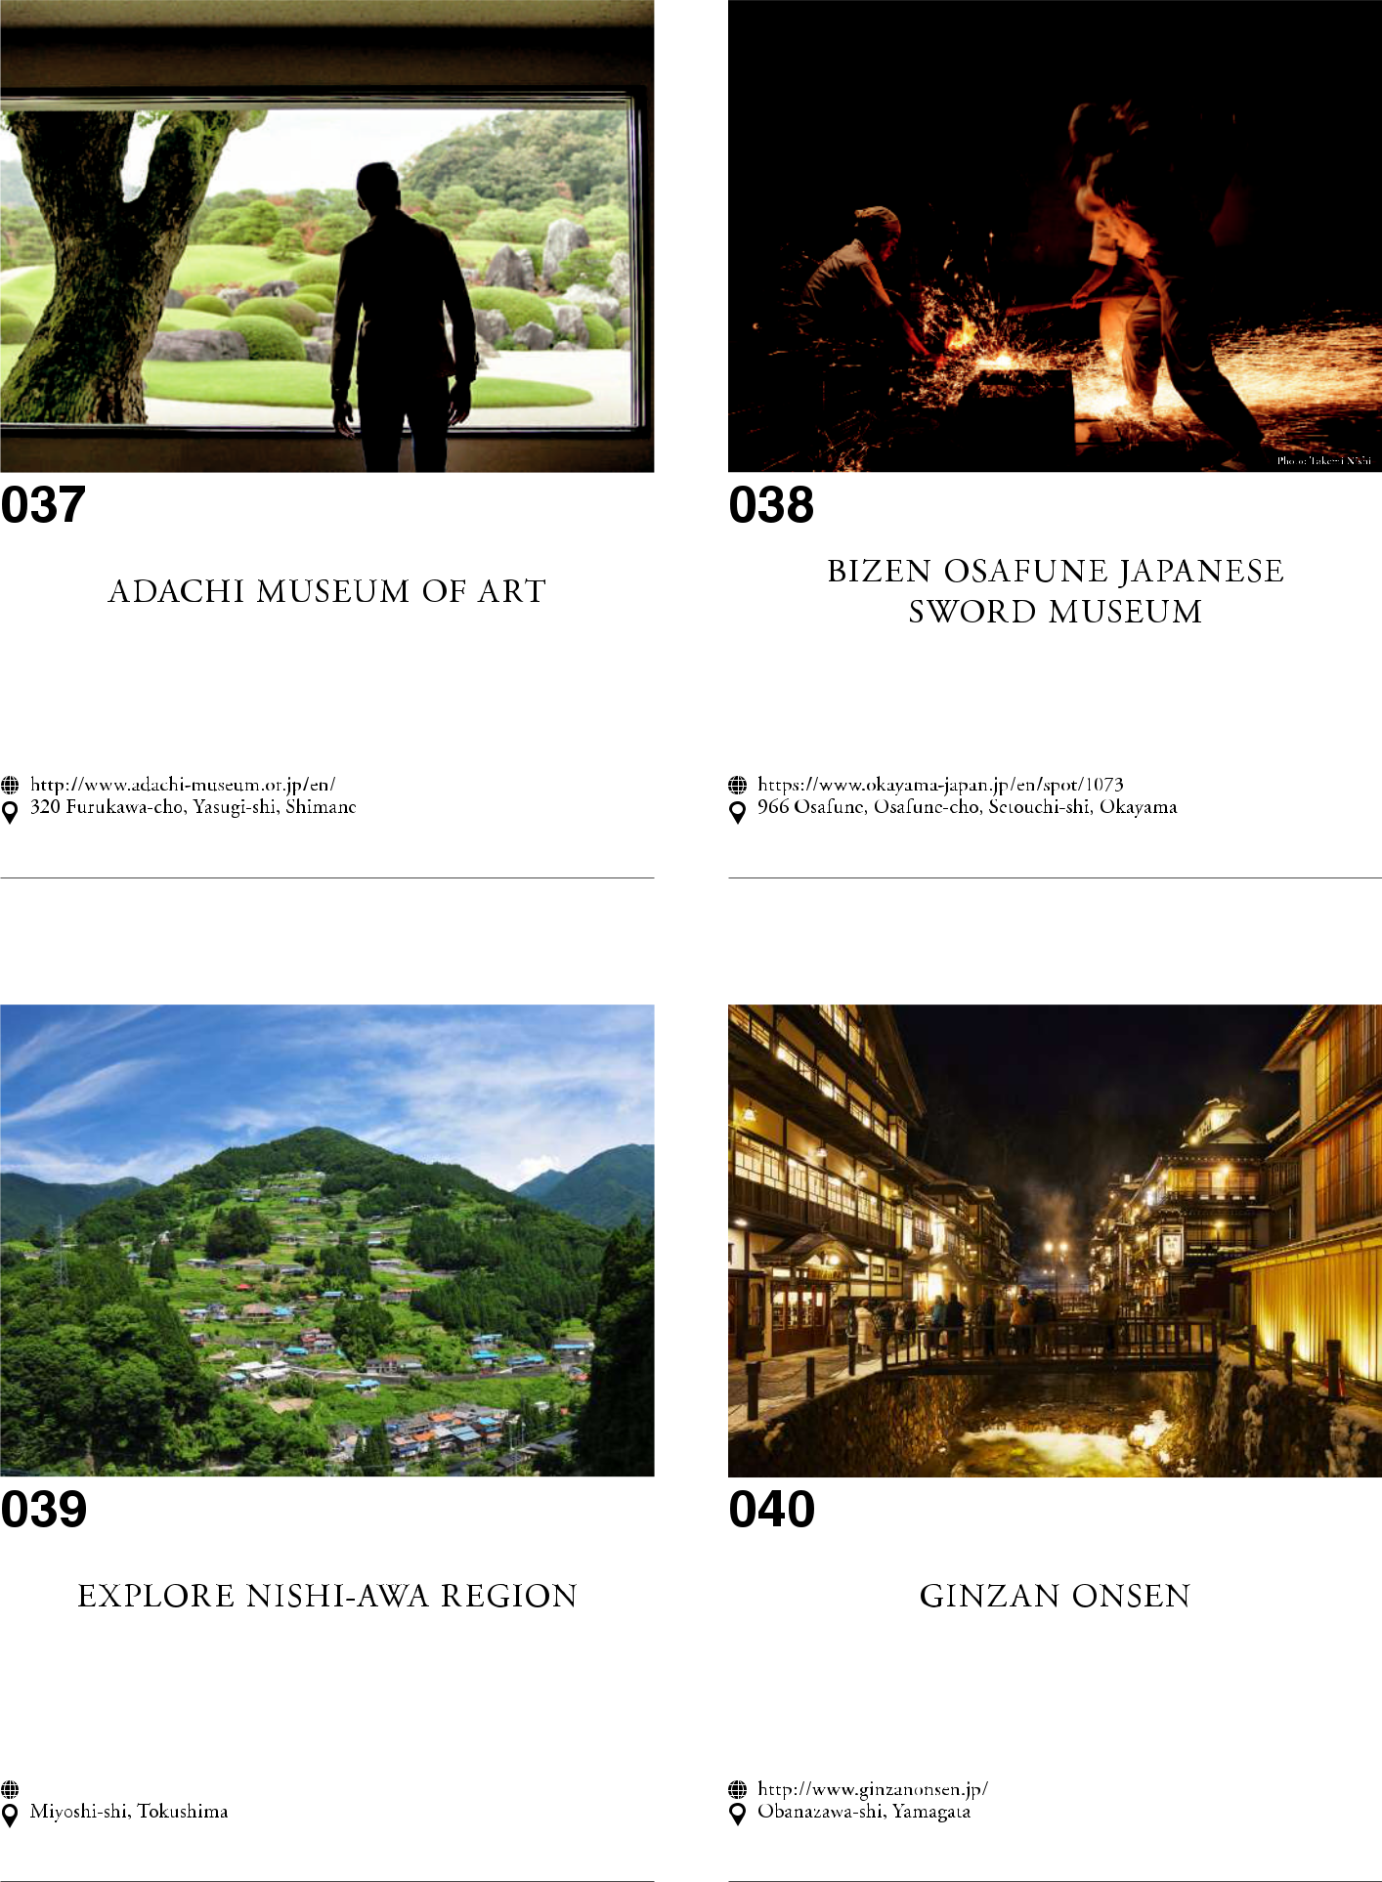

20

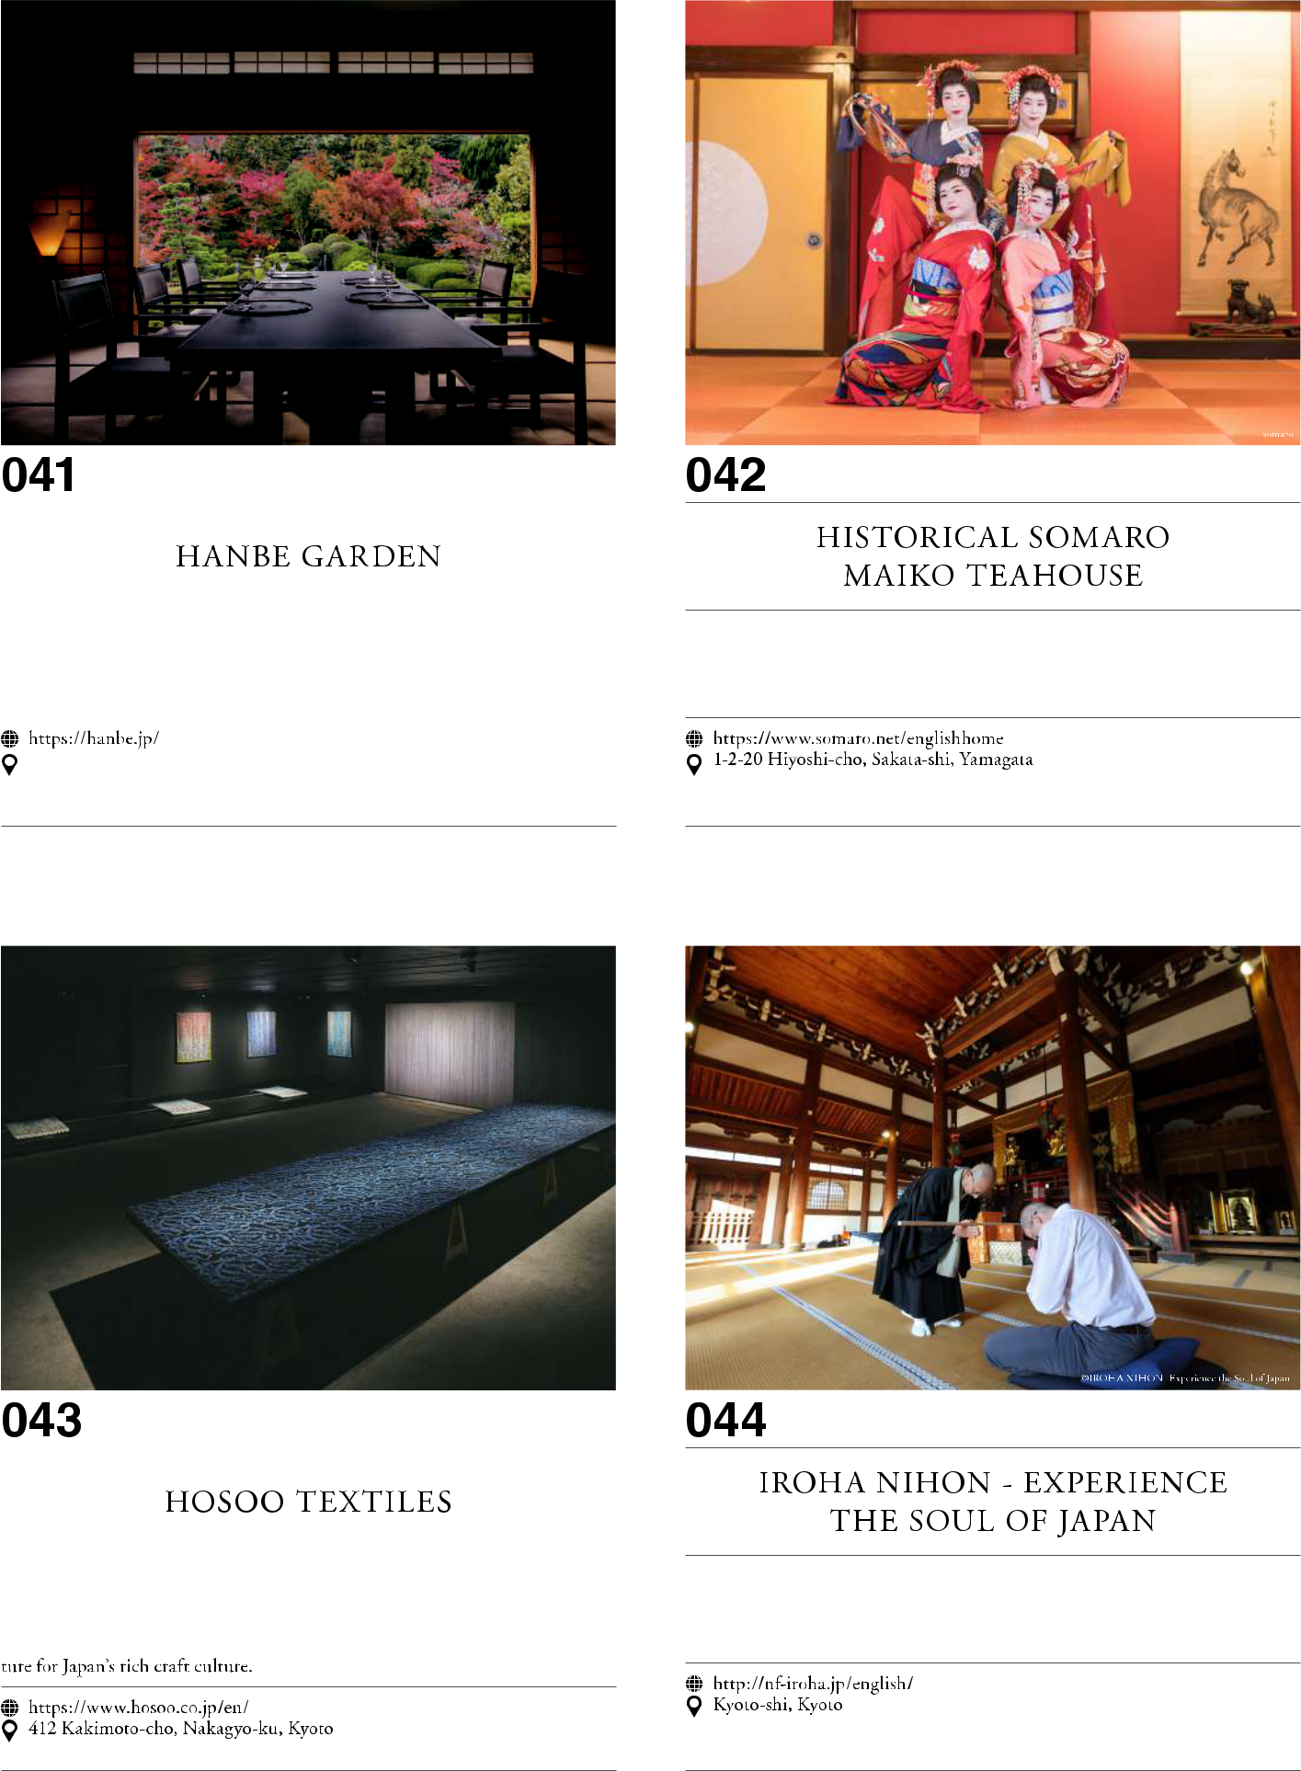

21

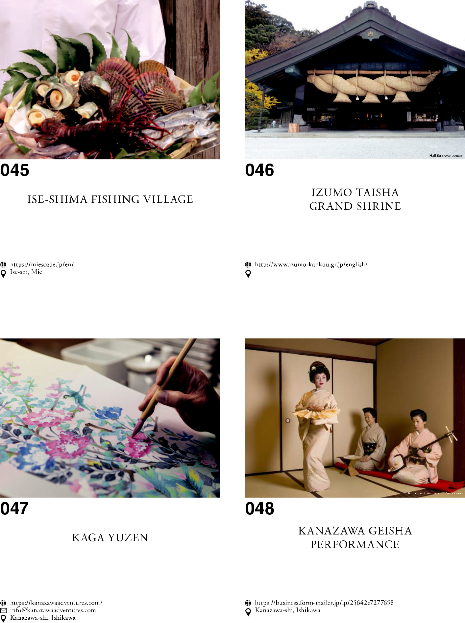

22

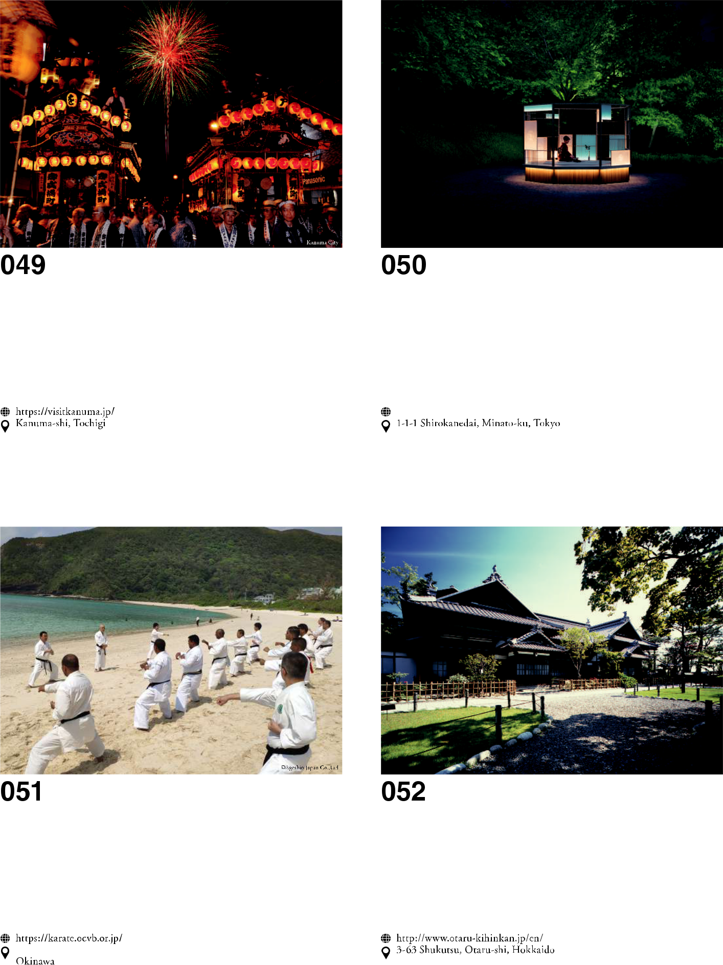

23

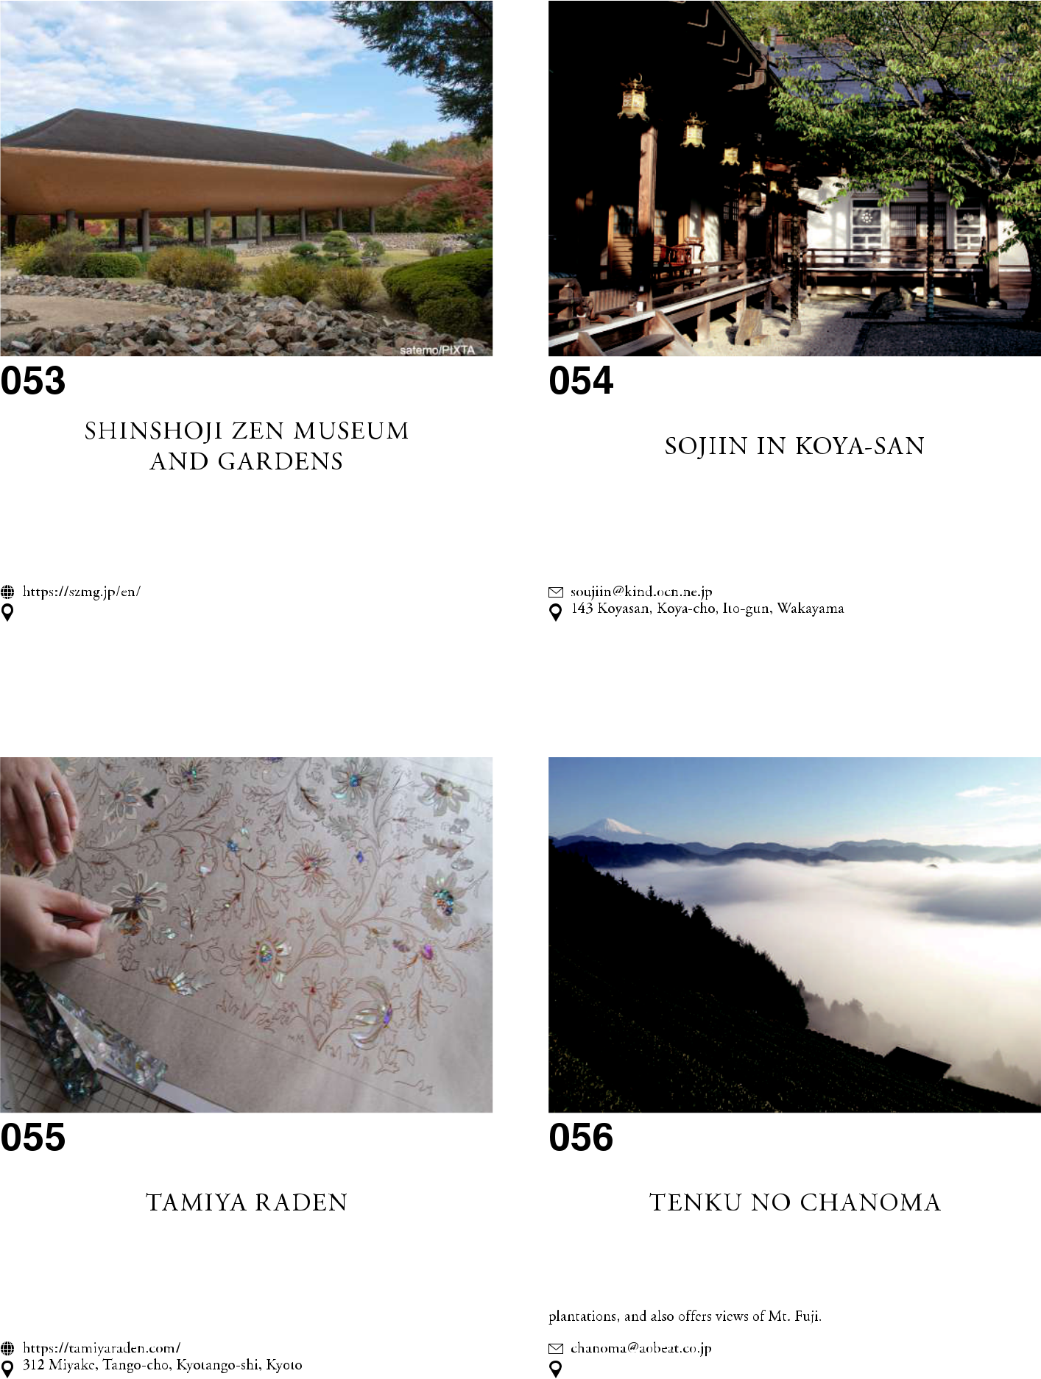

24

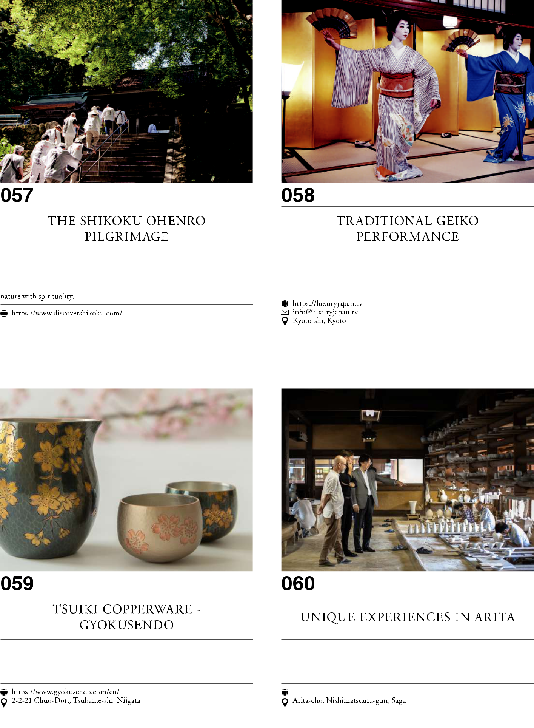

25

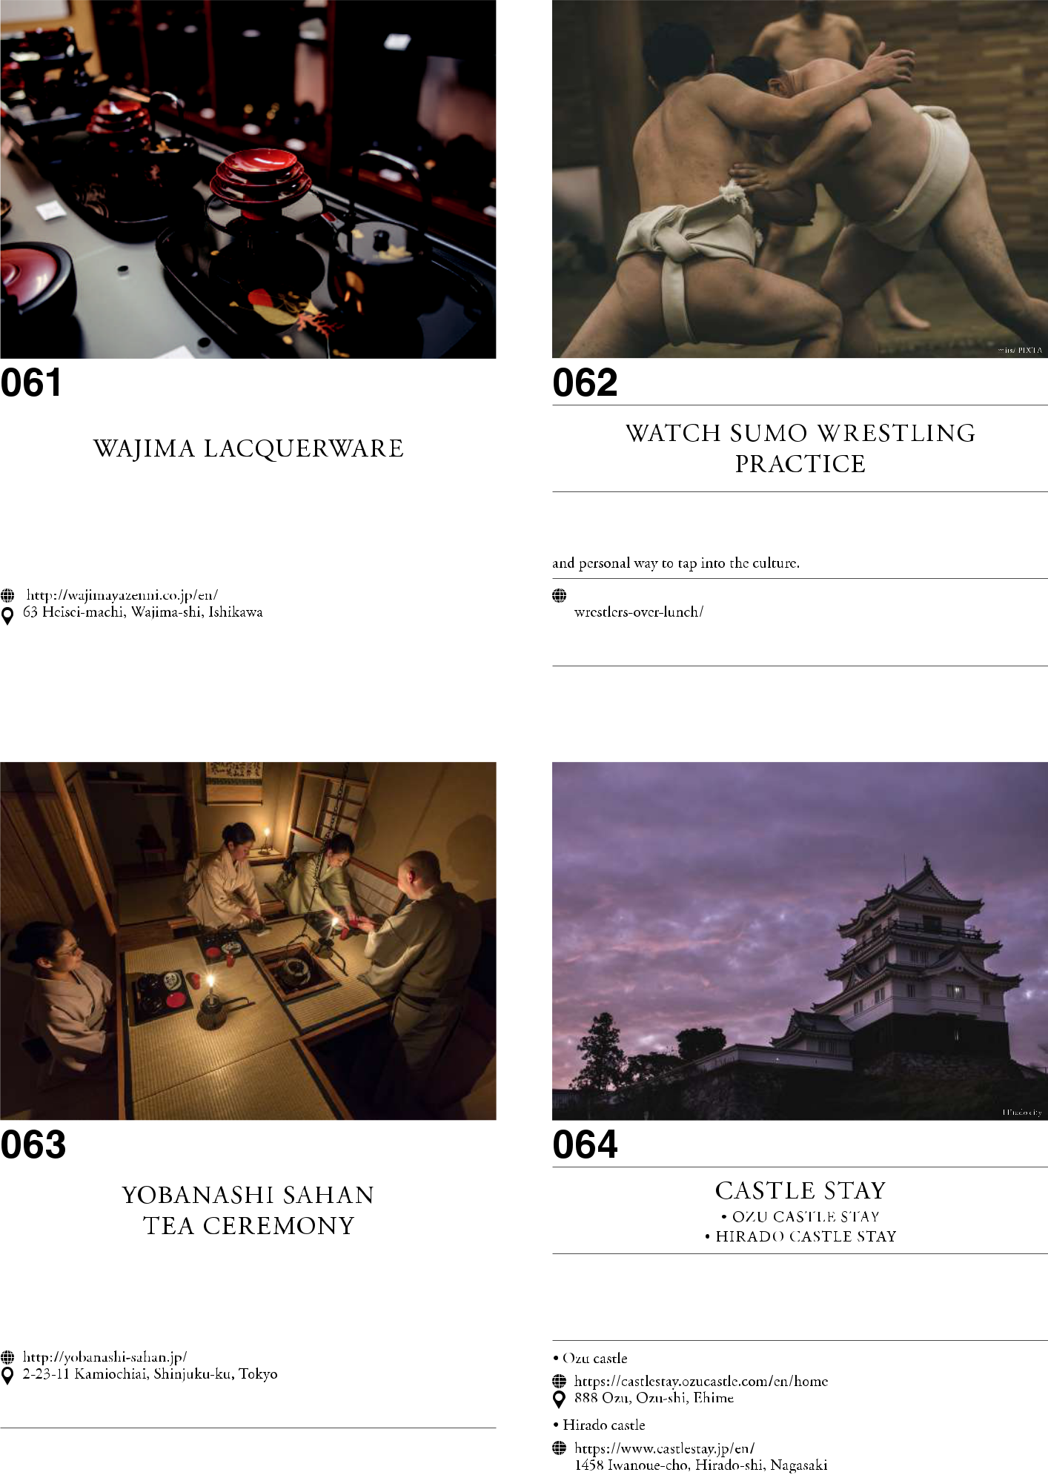

26



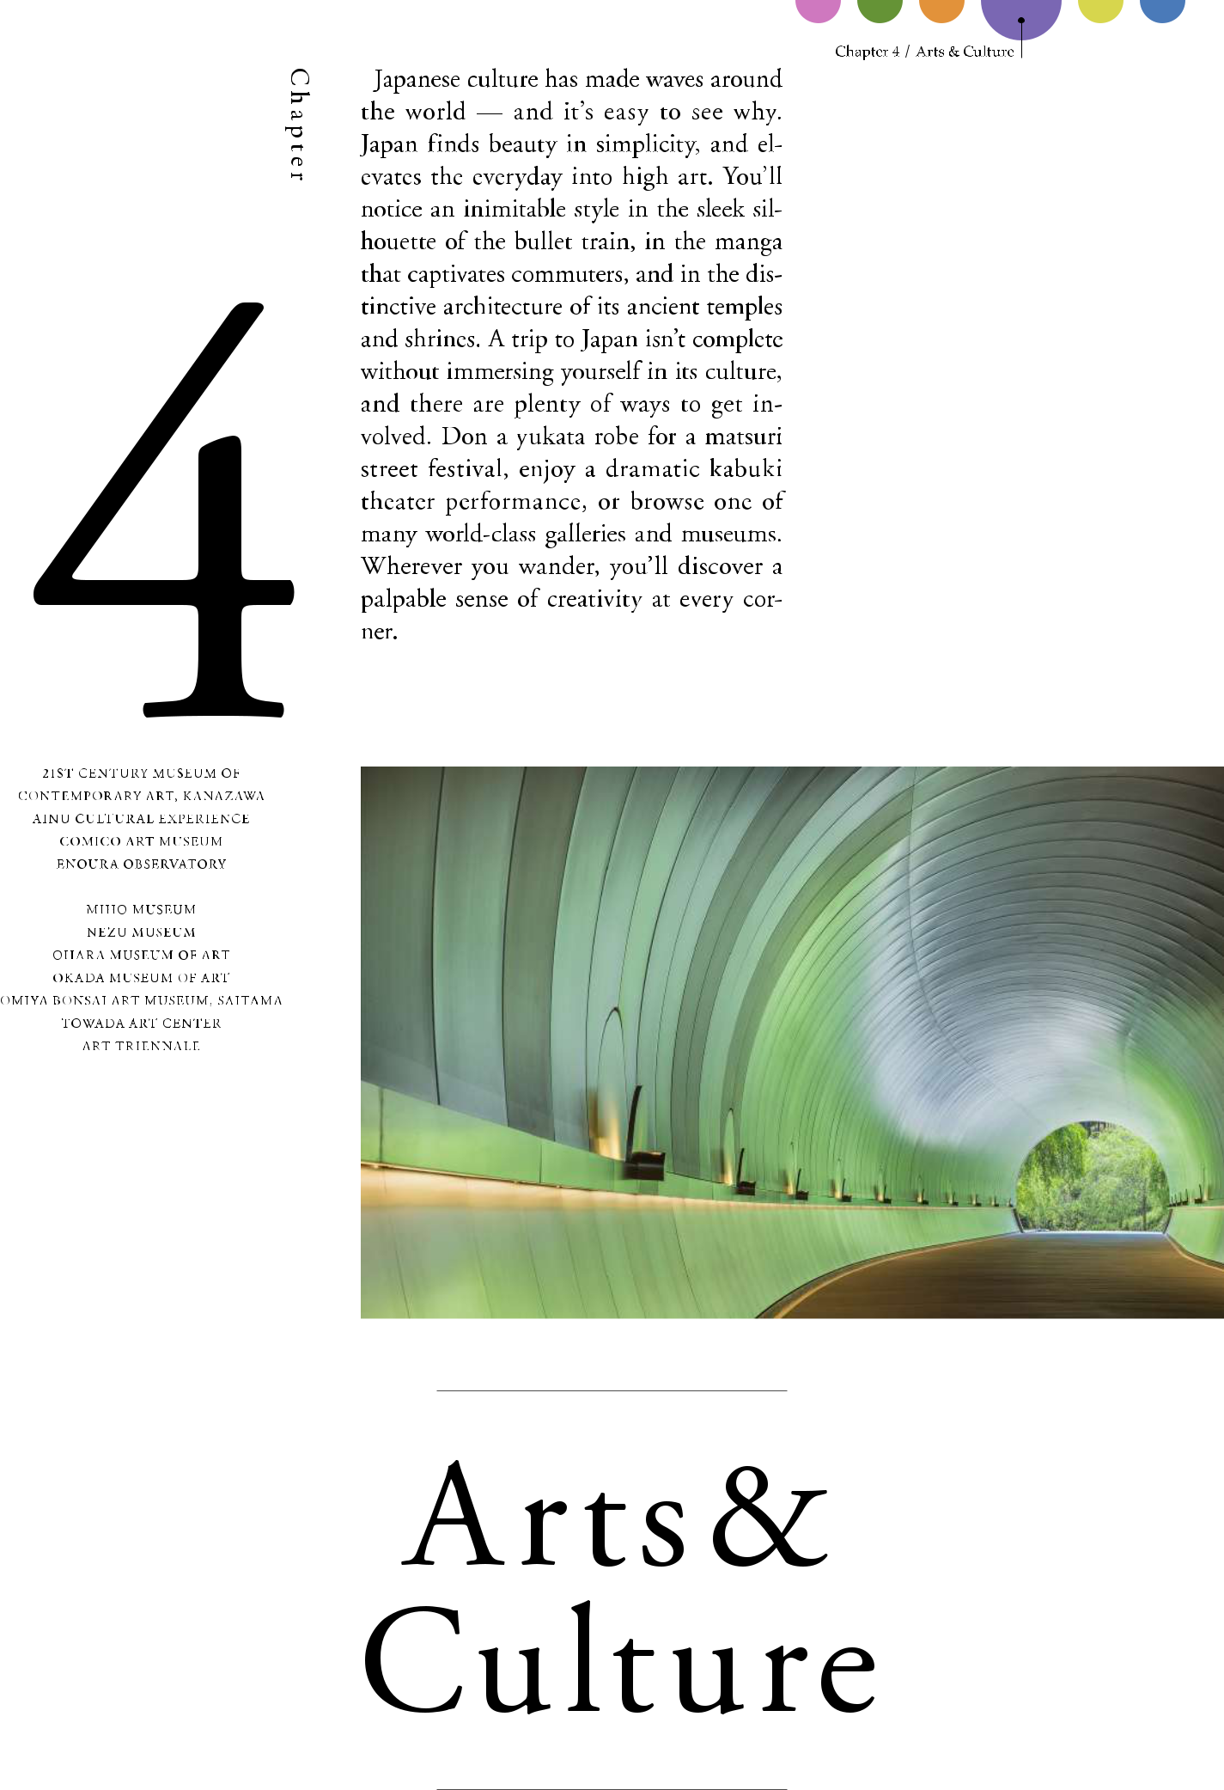

27

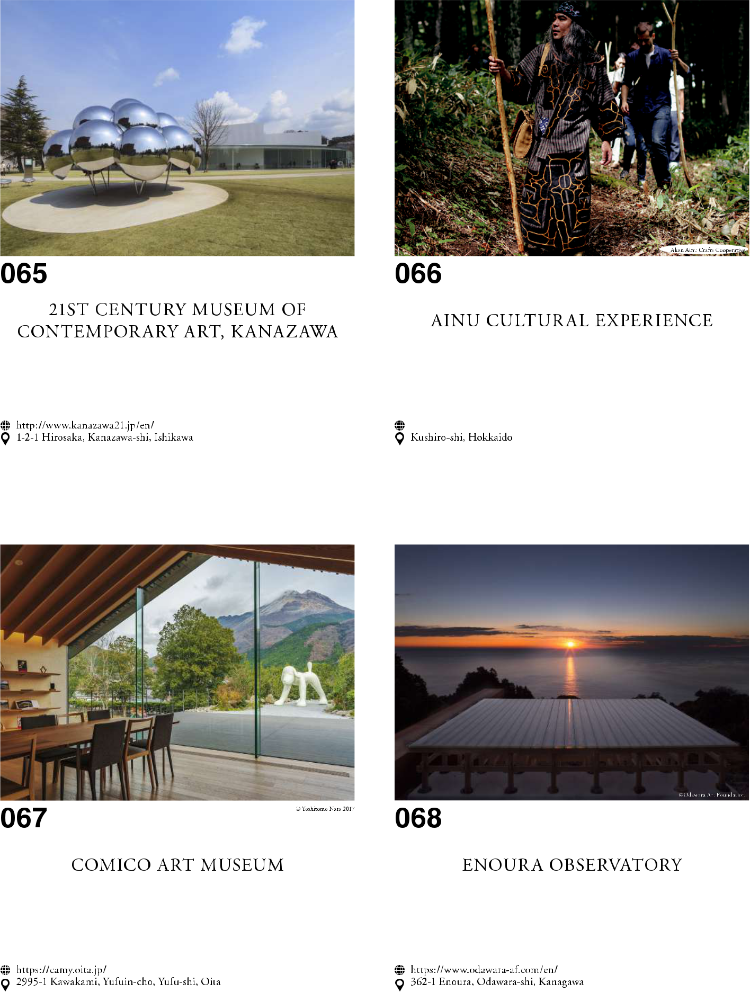

28

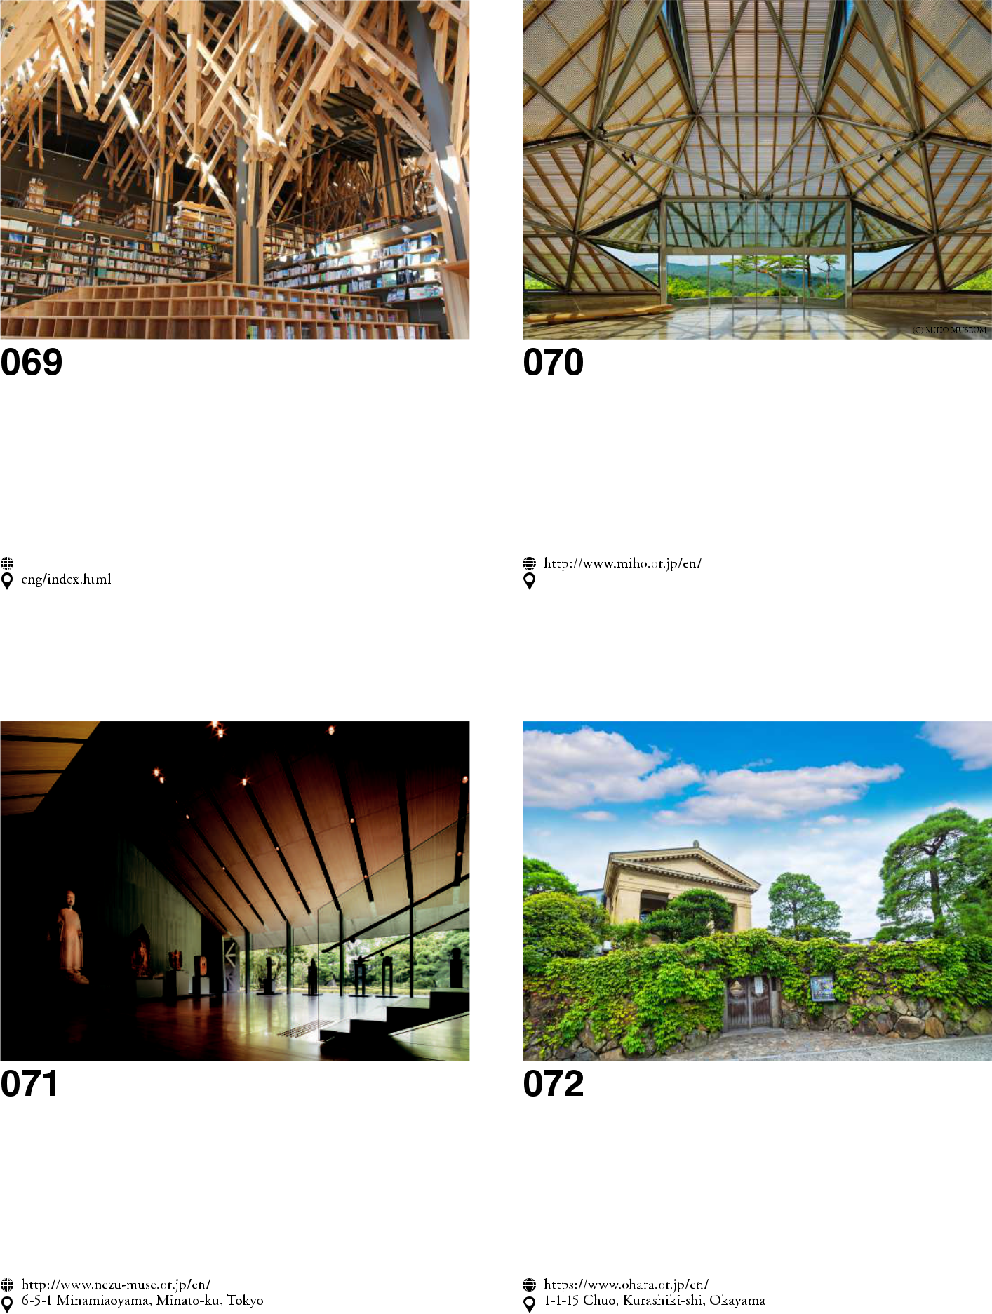

29

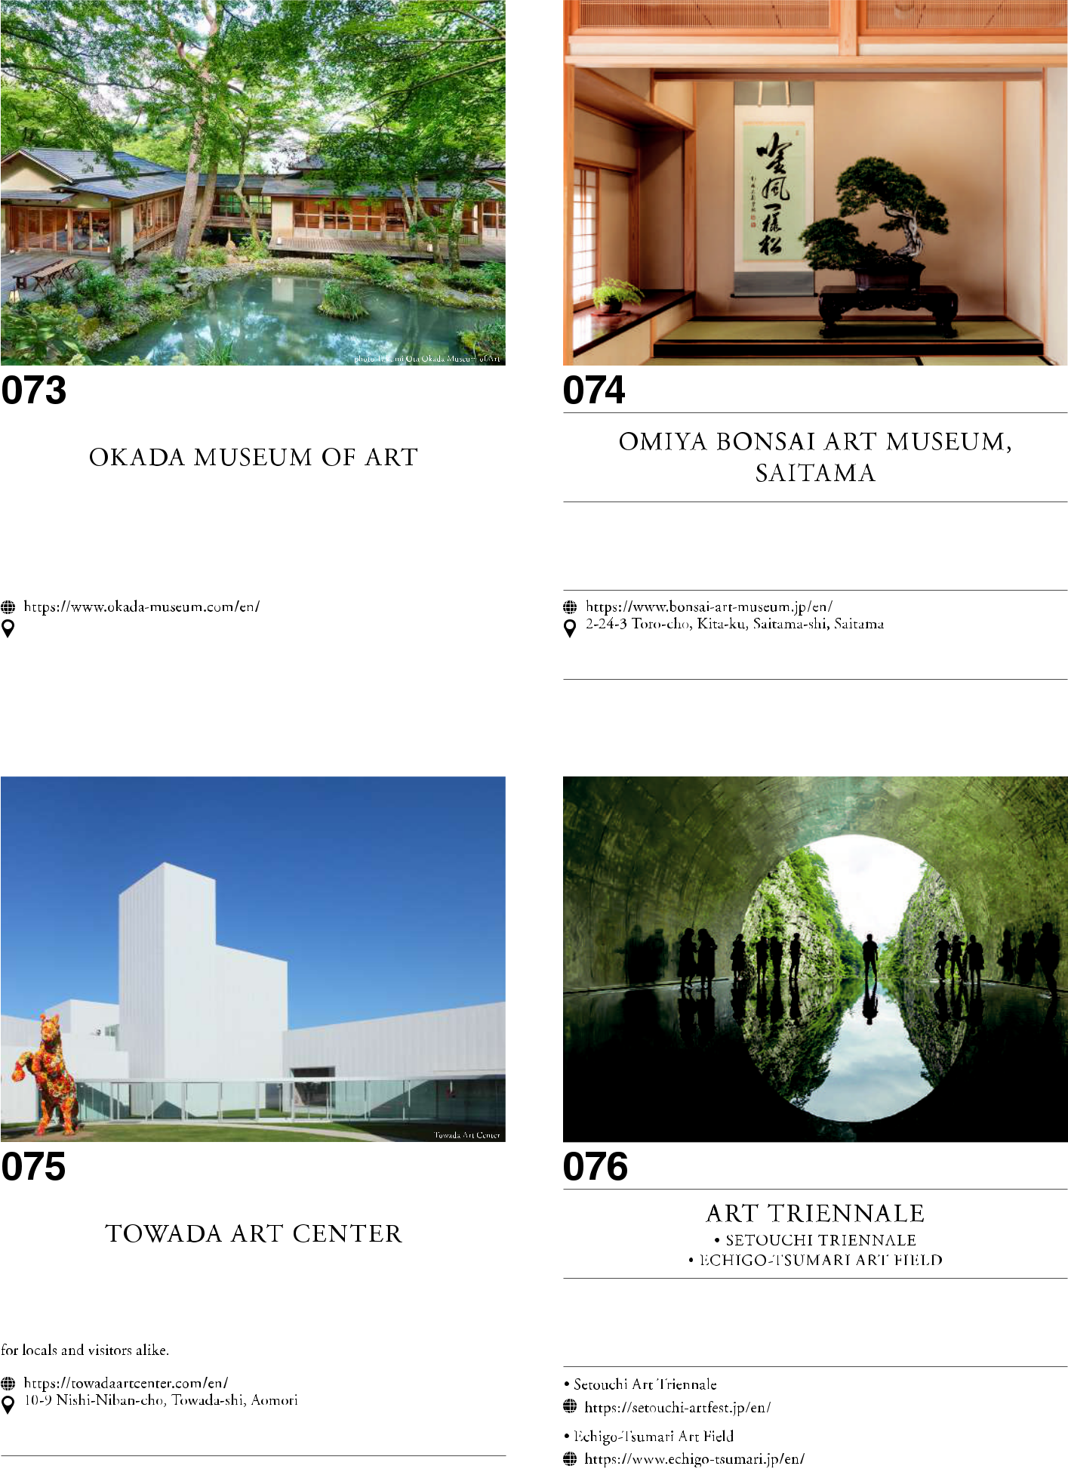

30

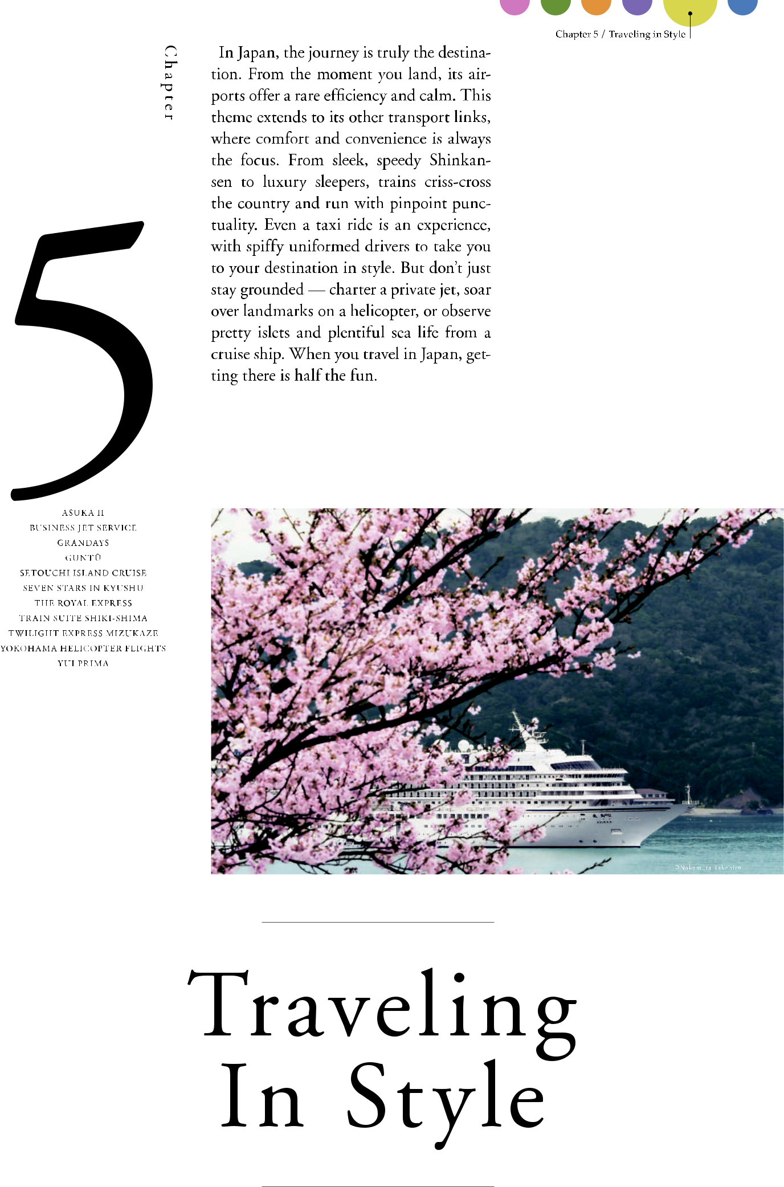

31

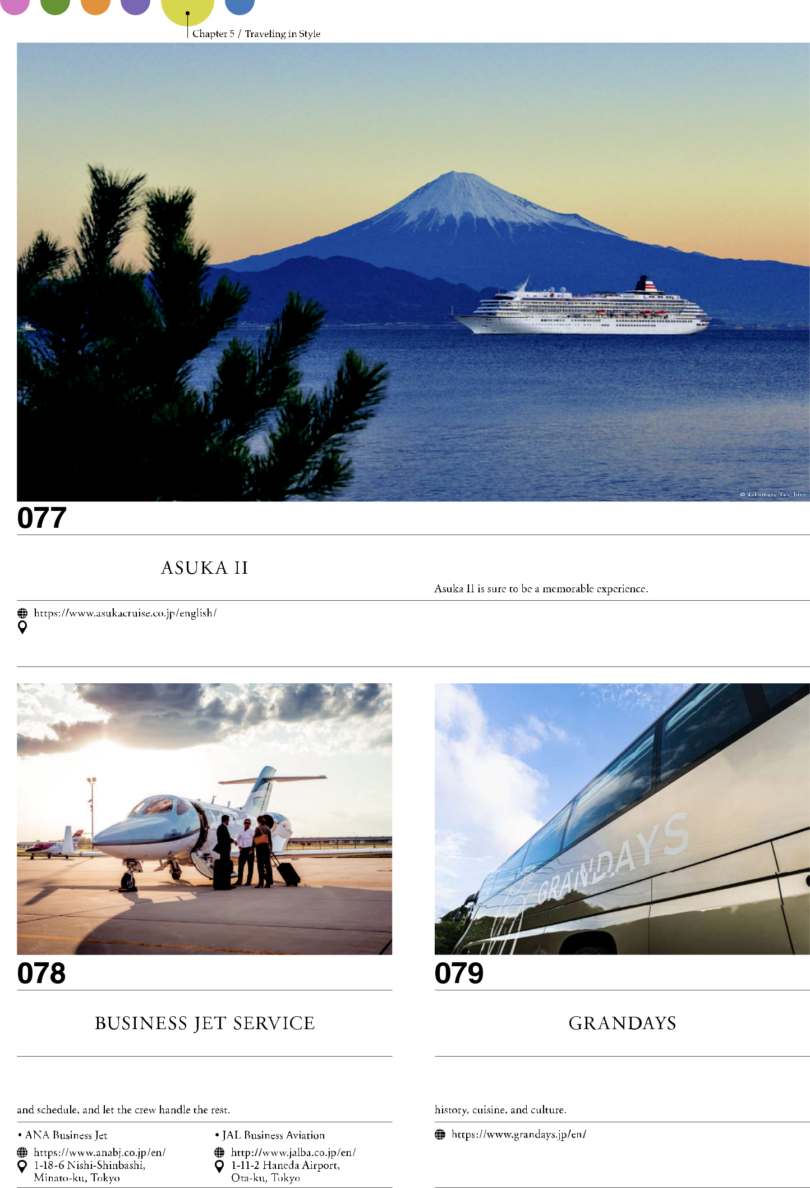

32

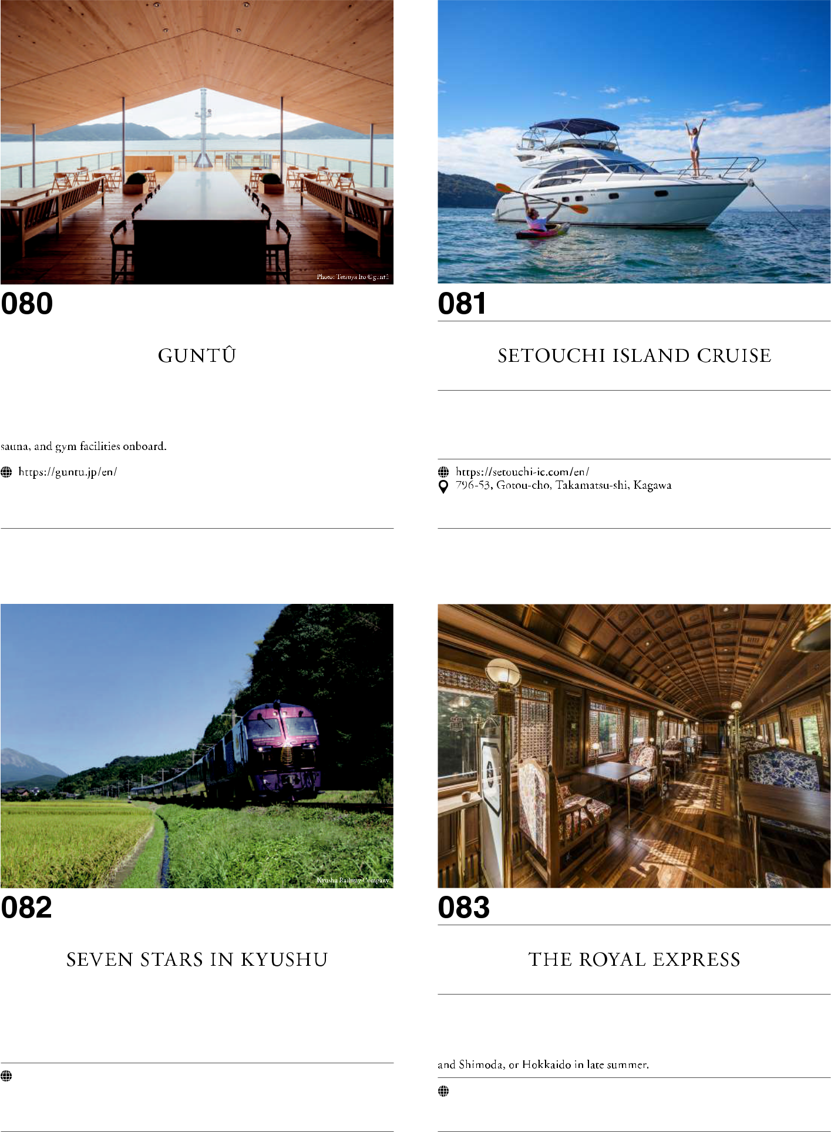

33

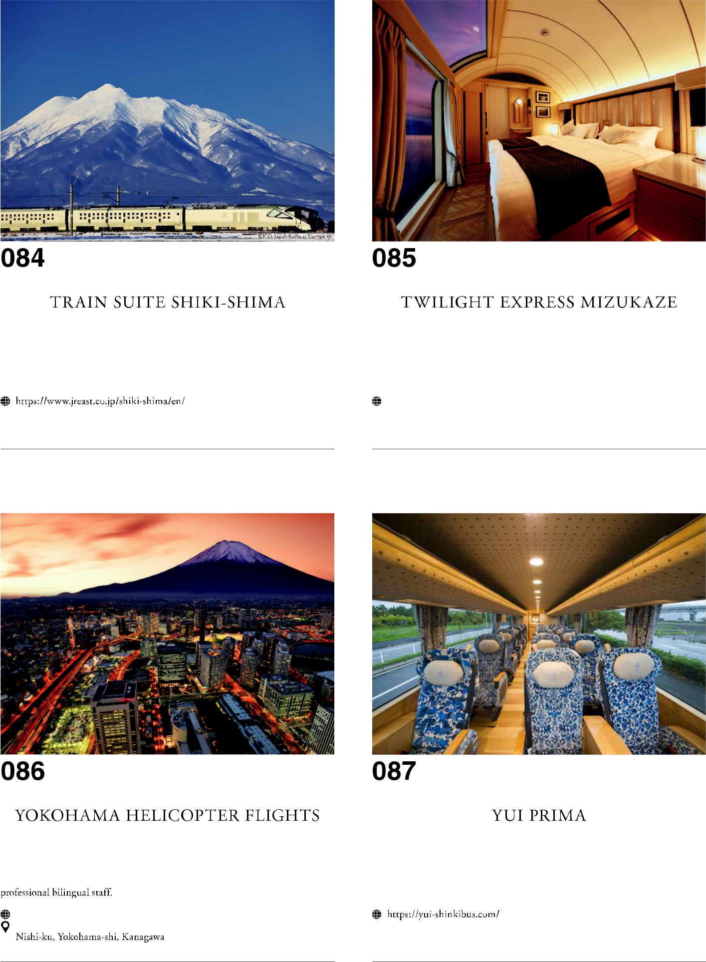

34

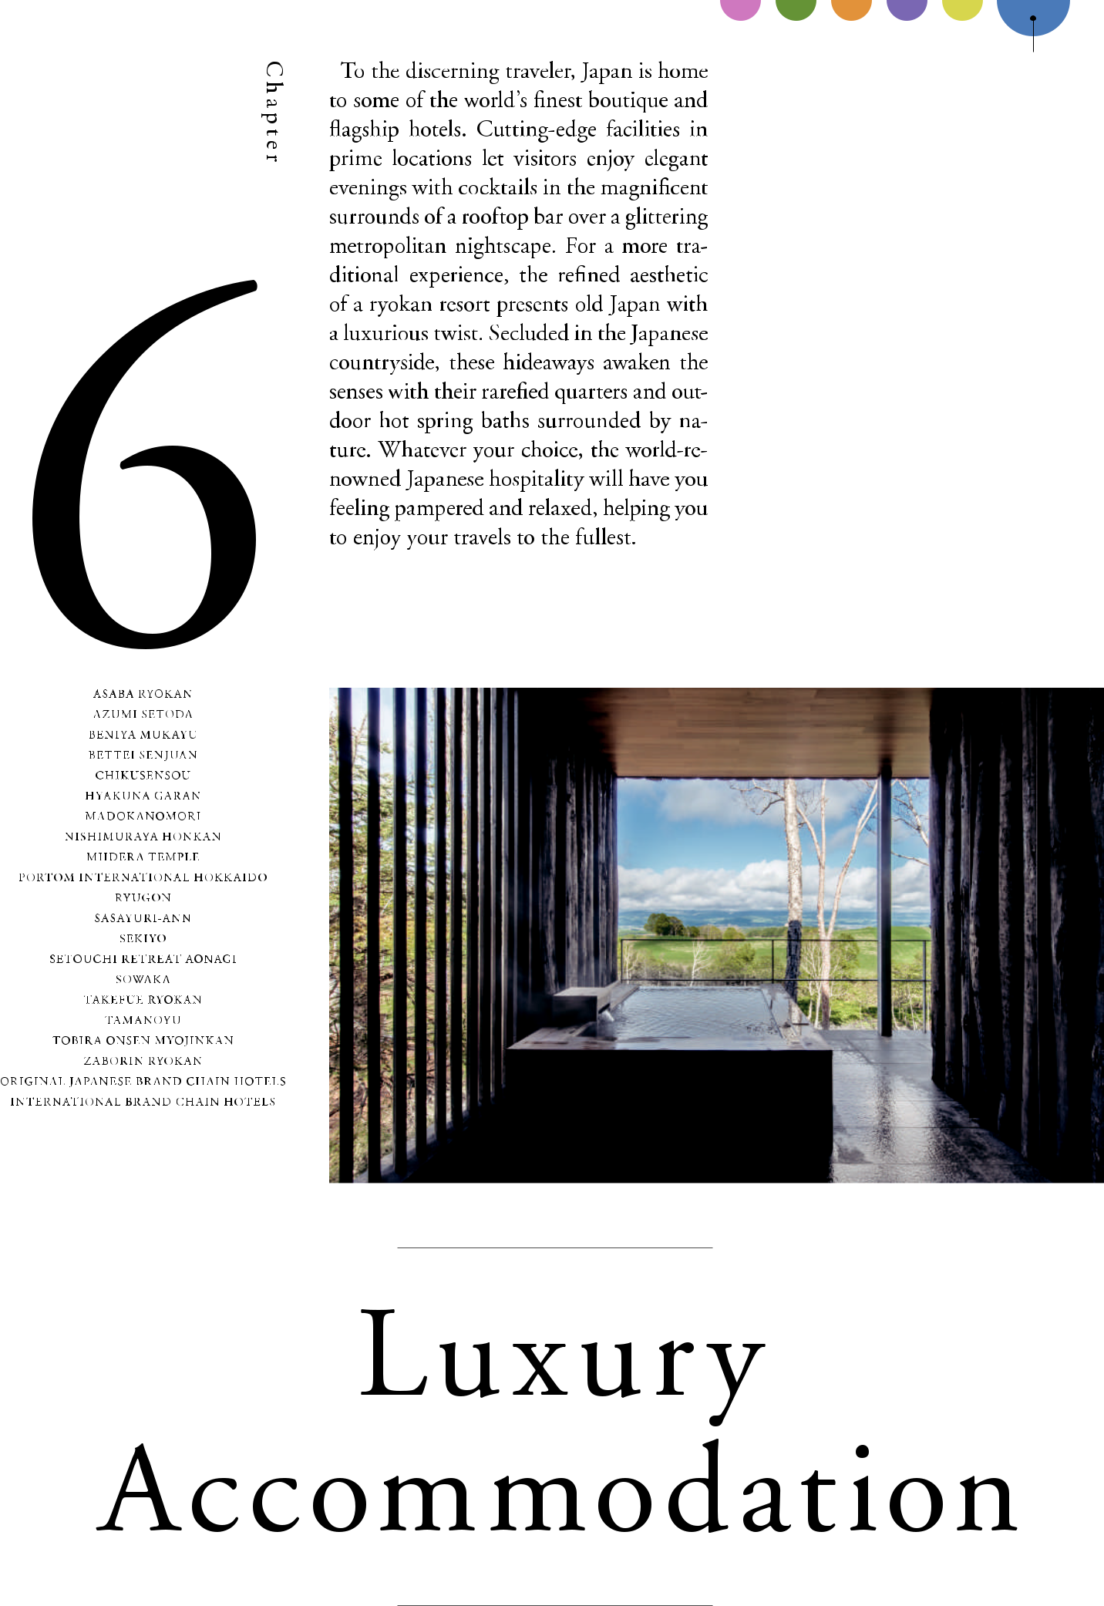

35

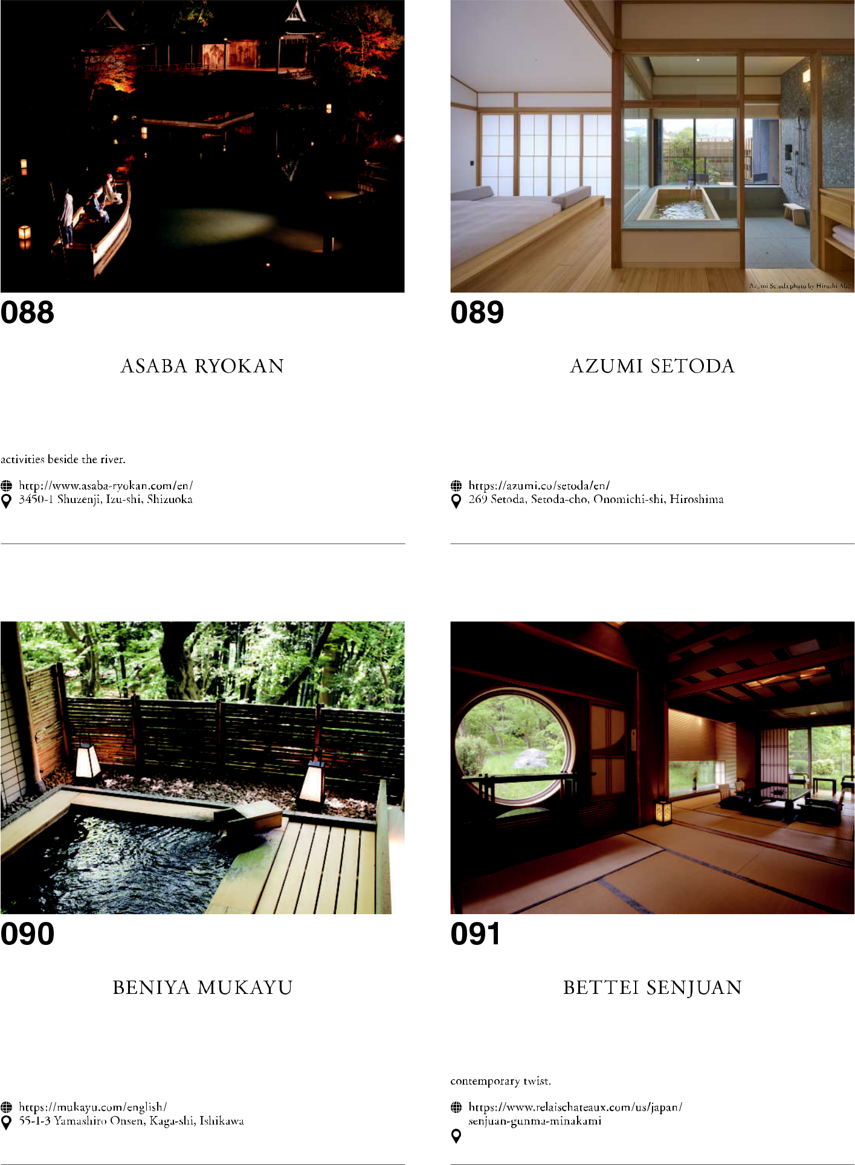

36

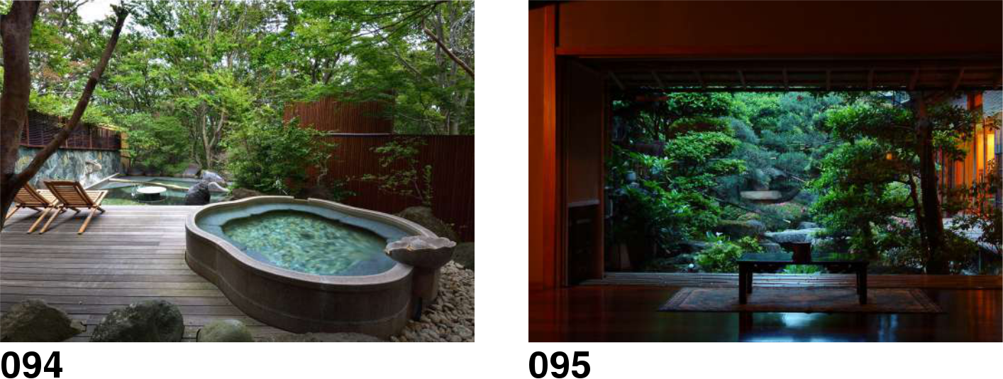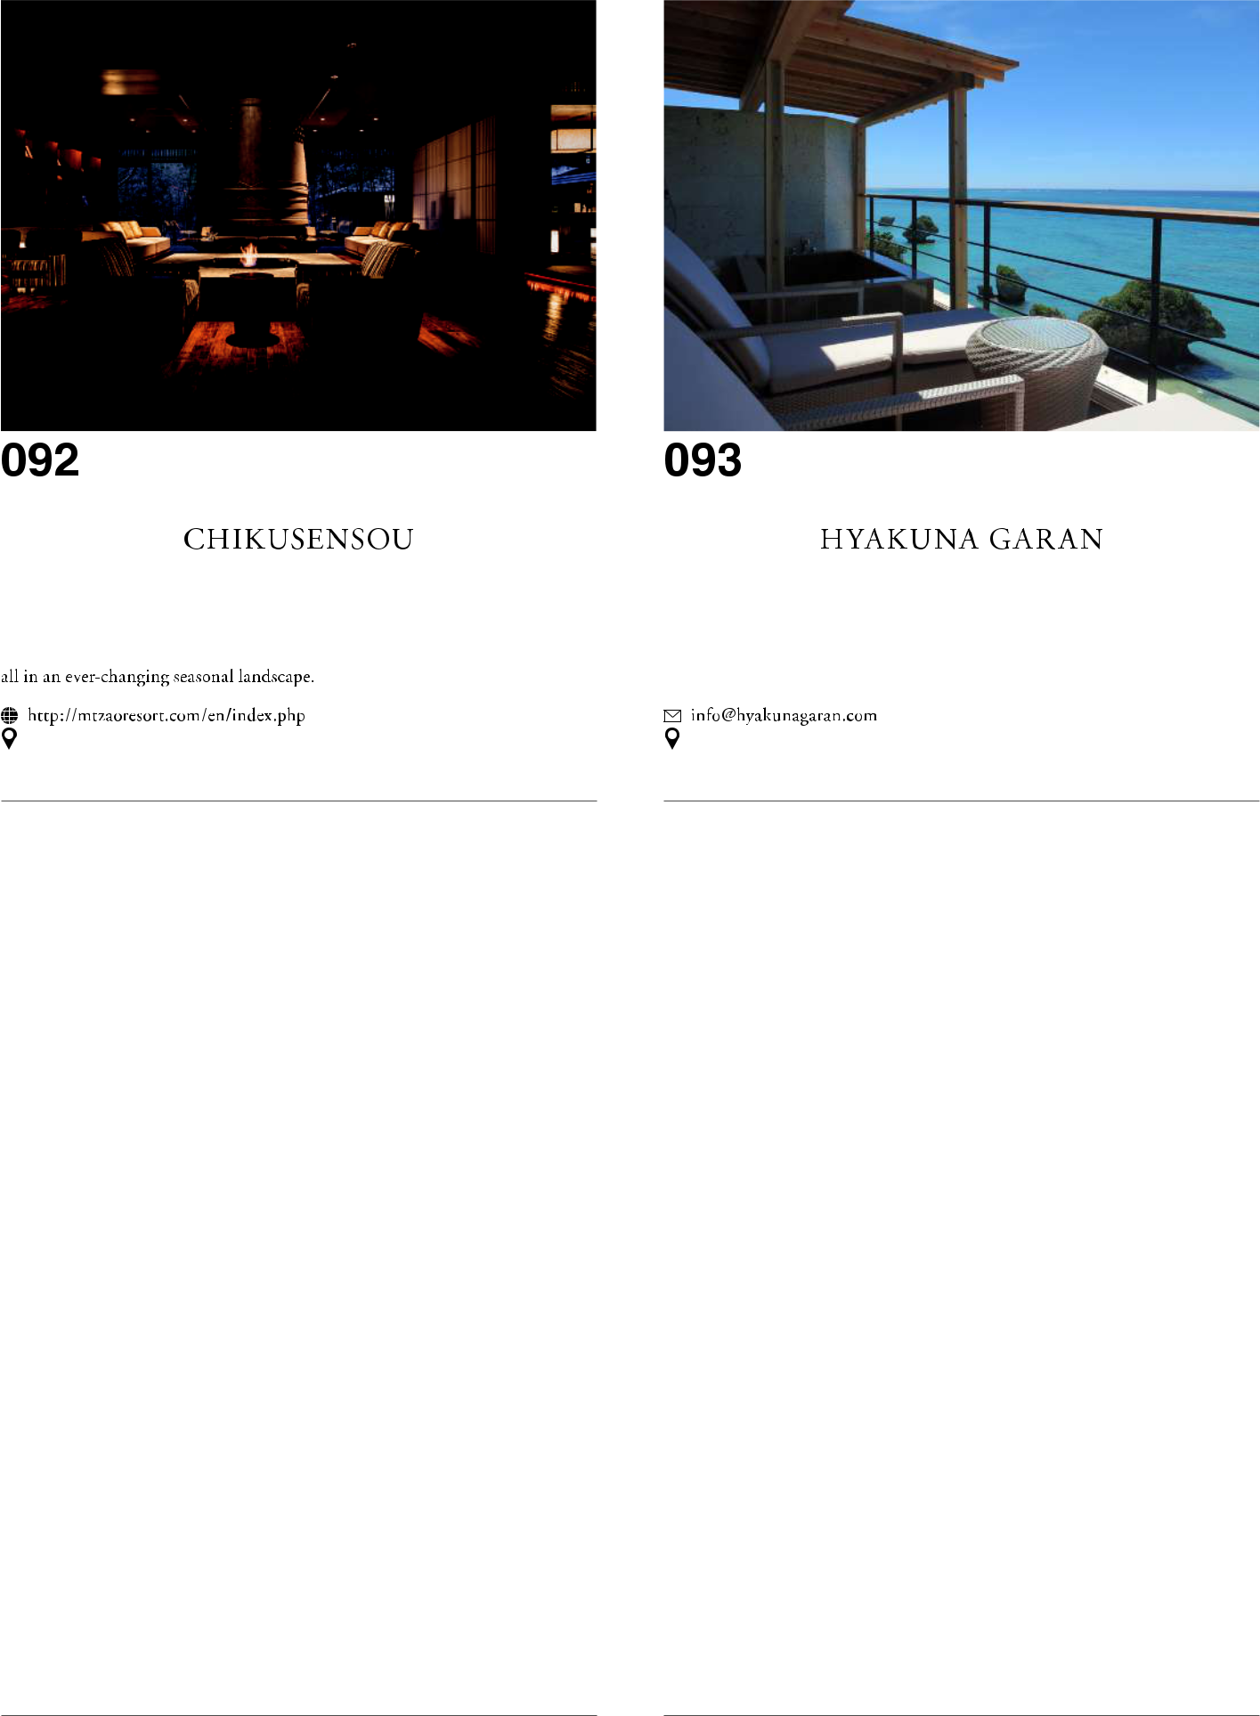

37

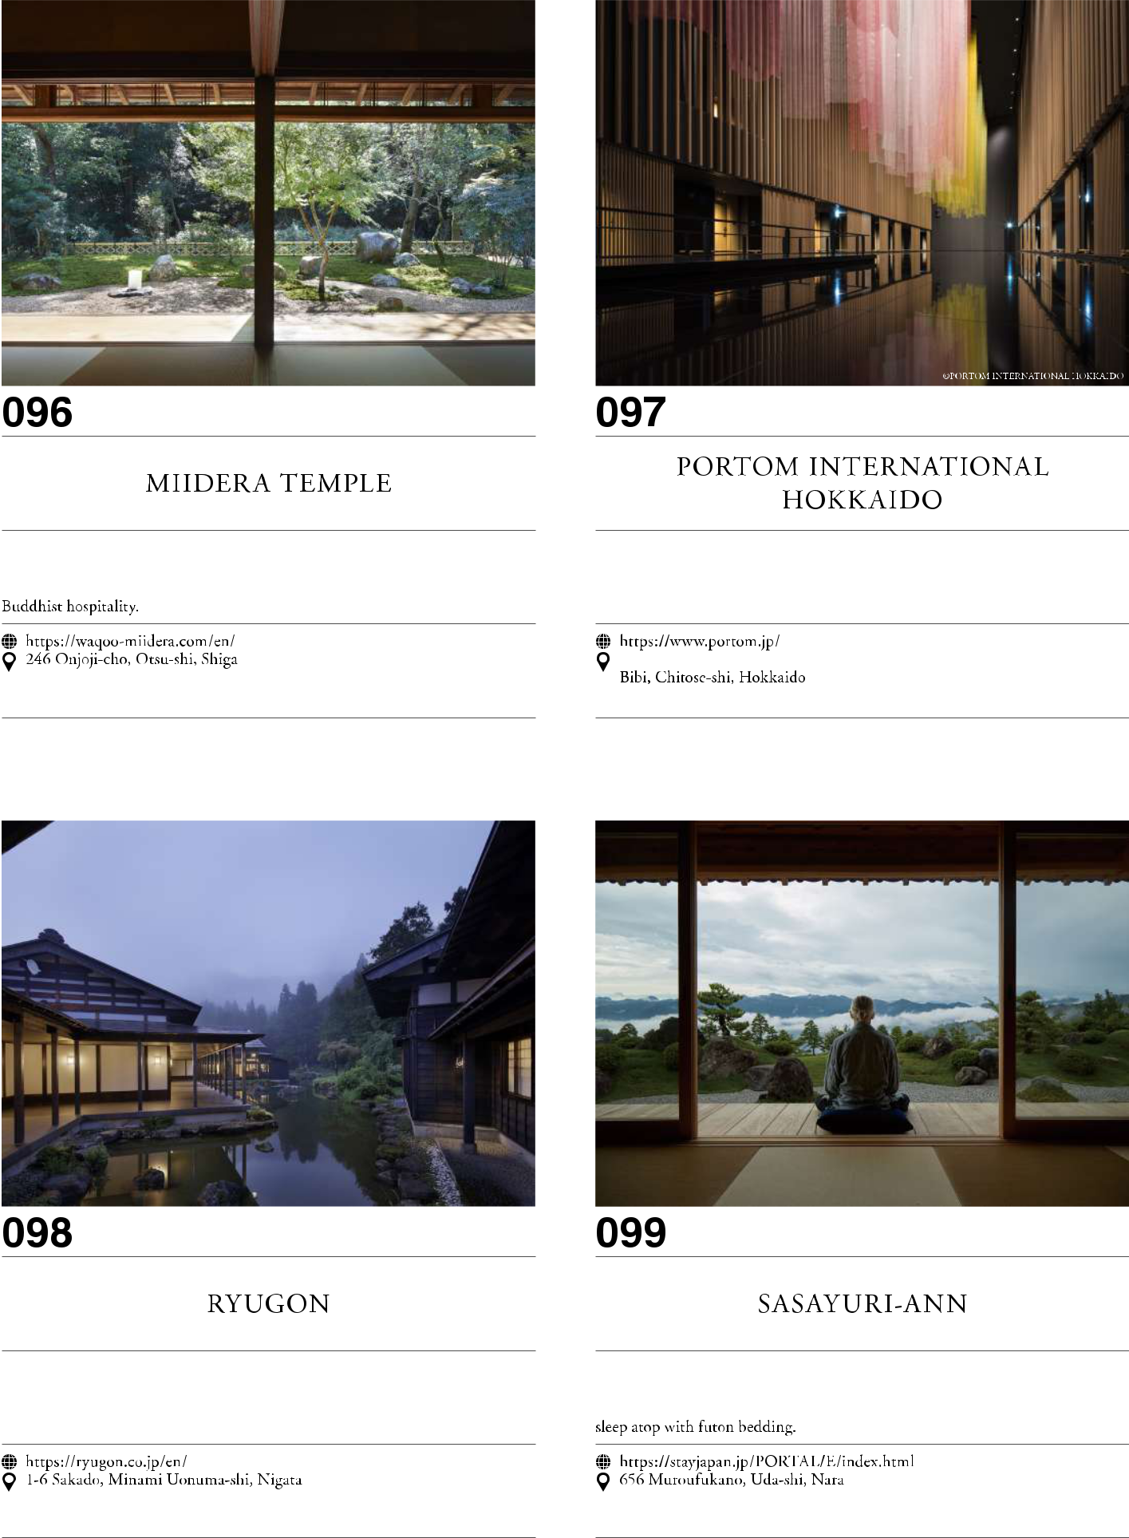

38

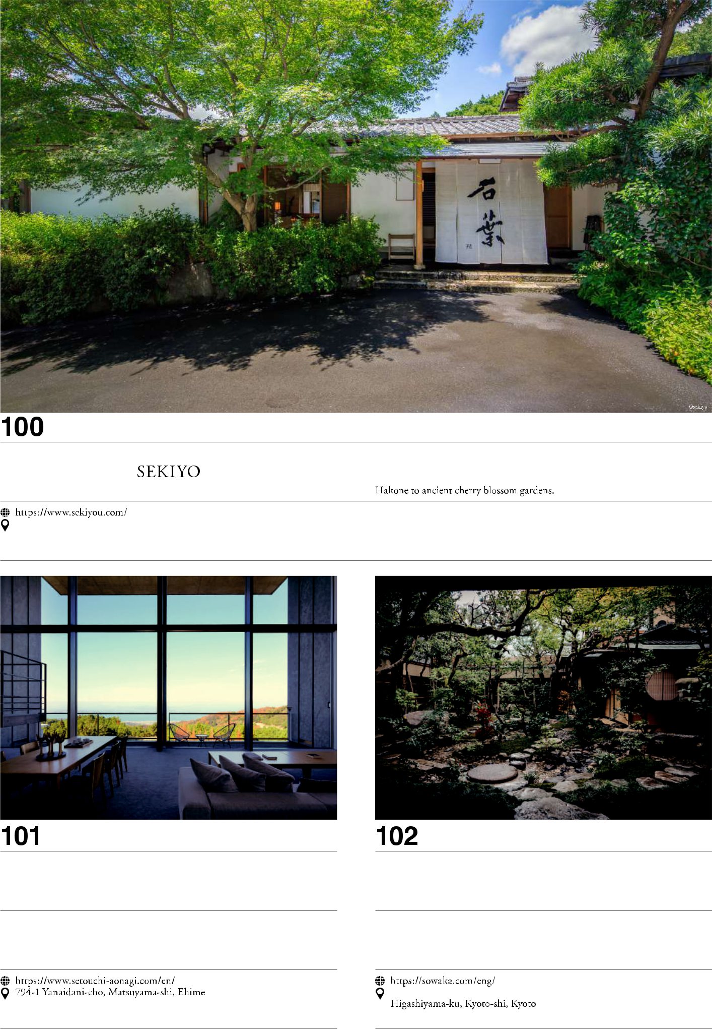

39

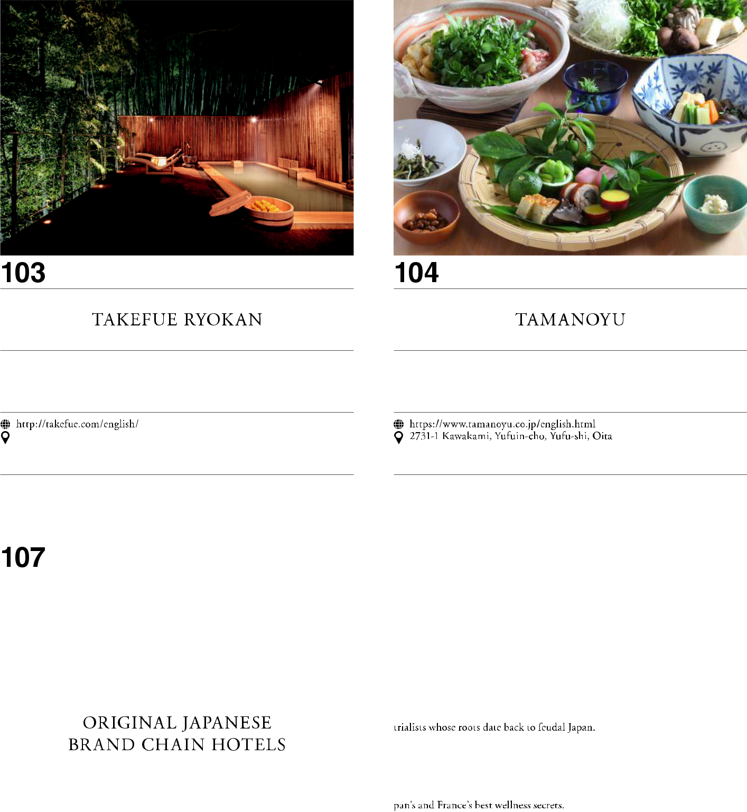

40

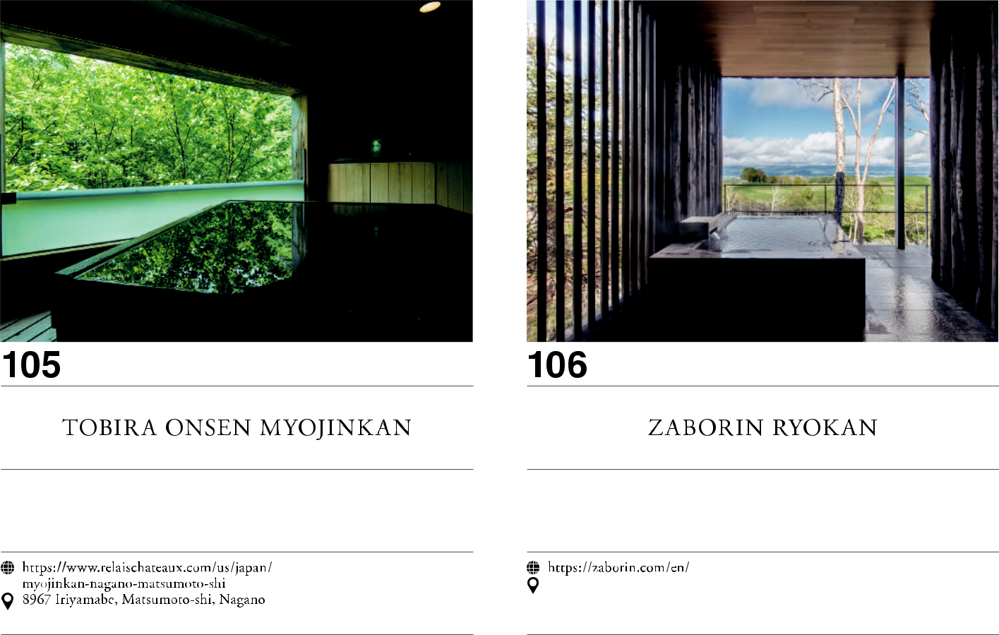

41



42



**Shin-Hakodate-Hokuto**

**HOKKAIDO**

**Shin-Aomori**

**AKITA**

**Hiroshima**

**Hakata**

**Akita****Morioka**

**Yamagata**

**YAMAGATA****Sendai**

**JOETSU** **Niigata**

|  |  |  |
| --- | --- | --- |
| **HOKURIKU** | **TOHOKU** |  |
| **Kanazawa** | **Nagano** |  |
|  |  |

**Tokyo**

**Kyoto** **TOKAIDO**

**Nagoya**

**Shin-Osaka**

**SANYO**

**KYUSHU**

**Okinawa**

**Kagoshima-Chuo**

43

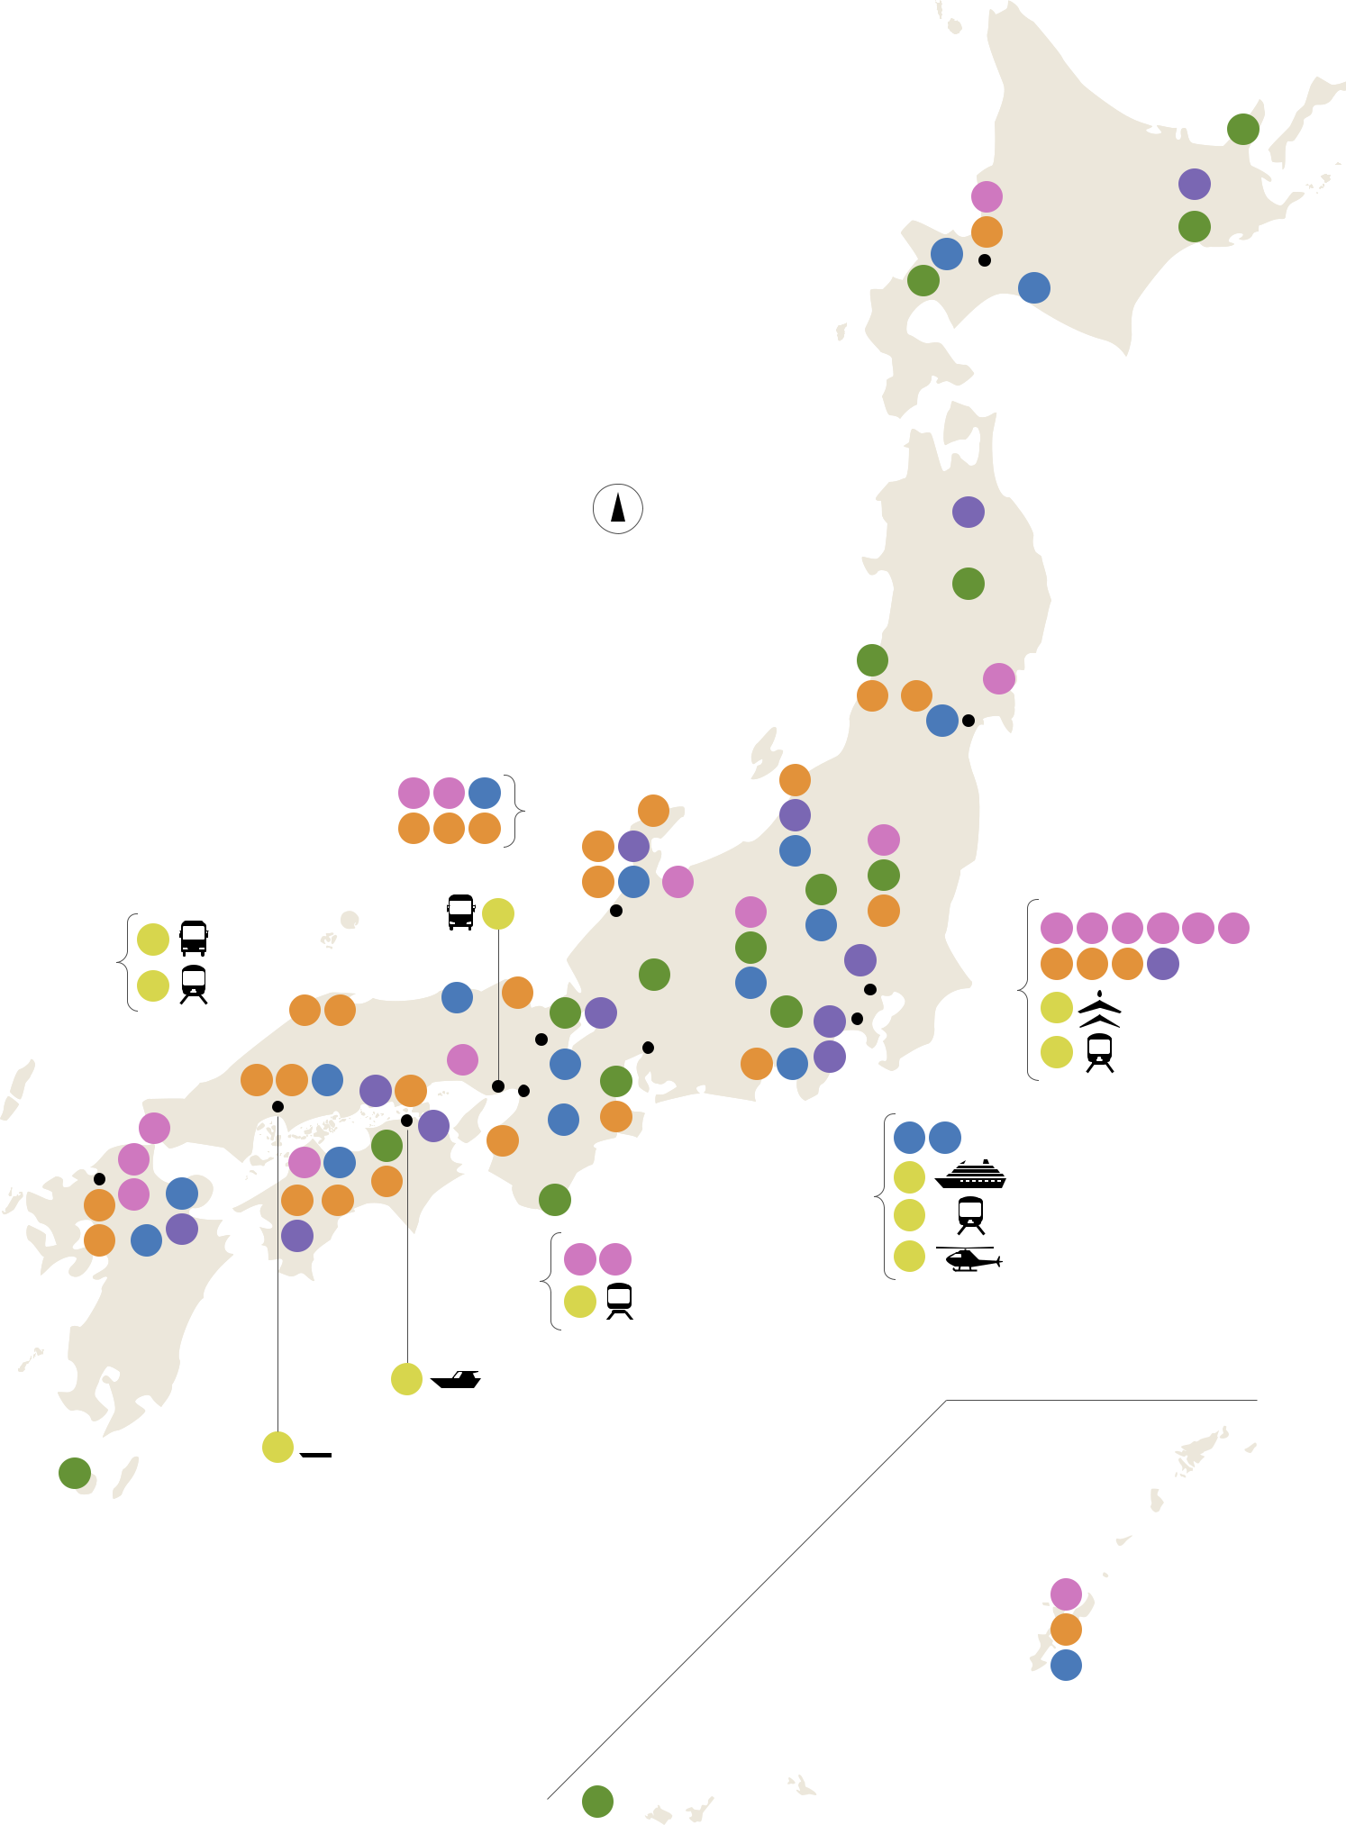

**030**

|  |  |  |  |  |  |
| --- | --- | --- | --- | --- | --- |
|  | **008** | | | **066** |  |
|  |  |  |
|  | **052** | | | **027** |  |
|  |  |  |
| **106** |  |  | **SAPPORO** |  |  |
|  |  |  |  |
| **033** | **097** | | |  |  |
|  |  |  |

N

north

|  |  |  |  |  |  |  |  |  |  |  |  |  |  |  |  |  |  |  |  |  |  |  |  |  |  |  |  |  |  |  |  |  |  |  |  |  |  |  |  |  |  |  |  |  |  |  |  |  |  |  |  |  |  |  |  |  |  |  |  |  |
| --- | --- | --- | --- | --- | --- | --- | --- | --- | --- | --- | --- | --- | --- | --- | --- | --- | --- | --- | --- | --- | --- | --- | --- | --- | --- | --- | --- | --- | --- | --- | --- | --- | --- | --- | --- | --- | --- | --- | --- | --- | --- | --- | --- | --- | --- | --- | --- | --- | --- | --- | --- | --- | --- | --- | --- | --- | --- | --- | --- | --- |
| **075** | | | | | | | | | | | | | | | | | | | | | | | | | | | | | | | | | | | | | | | | | | | | | | | | | | | | | | | | | | | |  |
| **031** | | | | | | | | | | | | | | | | | | | | | | | | | | | | | | | | | | | | | | | | | | | | | | | | | | | | | | | | | | | |  |
|  |  |  |  |  |  |  |  |  |  |  |  |  |  |  |  |  |  |  |  |  |  |  |  |  |  |  |  |  | **032** | | | | | |  |  |  |  |  |  | **019** | | |  |  |  |  |  |  |  |  |  |  |  |  |  |  |  |  |  |
|  |  |  |  |  |  |  |  |  |  |  |  |  |  |  |  |  |  |  |  |  |  |  |  |  |  |  |  |  | **042** | | | | | | **040** | |  |  |  |  |  |  |  |  |  |  |  |  |  |  |  |  |  |  |  |  |  |
|  |  |  |  |  |  |  |  |  |  |  |  |  |  |  |  |  |  |  |  |  |  |  |  |  |  |  |  |  |  |  |  |  |  |  |  |  |  |  |  |  |  |  |  |  |  |  |  |  |  |  |  |  |
|  |  |  |  |  |  |  |  |  |  |  | **004** | | **005** | **102** | |  |  |  |  |  |  |  |  |  |  |  |  | **059** |  |  |  |  |  |  |  | **092** |  |  | **SENDAI** | | | | | | |  |  |  |  |  |  |  |  |  |  |  |  |  |  |  |
|  |  |  |  |  |  |  |  |  |  |  |  |  |  |  |  |  |  |  |  |  |  |  |  |  |  |  |  |  |  |  |  |  |  |  |  |  |  |  |  |  |  |  |  |  |  |  |
|  | | | | | | | | | | |  | | | | | | | | | | | |  | | | | | | | | | | | | | | | | | | | | | | | | | | | | | | |  |
|  |  |  |  |  |  |  |  |  |  |  |  |  |  |  |  |  |  | **061** | | | |  |  |  |  |  |  |  |  |  |  |  |  |  |  |  |  |  |  |  |  |  |  |  |  |  |  |  |  |  |  |  |  |  |  |
|  |  |  |  |  |  |  |  |  |  |  | **043** | | **044** | **058** | |  |  |  |  |  |  |  |  | **076b** | | | | | | |  |  |  |  |  |  |  |  |  |  |  |  |  |  |  |  |  |  |  |  |  |  |  |  |  |  |
|  |  |  |  |  |  |  |  |  |  |  |  |  |  |  |  |  |  |  |  |  |  |  |  |  |  |  |  |  |  |  |  |  |  |  |  |  |  |  |  |  |  |  |  |  |
|  |  |  |  |  |  |  |  |  |  |  |  |  |  |  |  | **047** | | **065** | | |  |  |  | **012** | | | | | |  |  |  |  |  |  |  |  |  |  |  |  |  |  |  |  |  |  |  |  |  |  |  |  |  |  |
|  |  |  |  |  |  |  |  |  |  |  |  |  |  |  |  |  |  |  |  |  |  |  | **098** |  |  |  |  |  |  |  |  |  |  |  |  |  |  |  |  |  |  |  |  |  |  |  |  |  |  |
|  | | | | | | | | | | | | | | | | | | | | |  | |  | | | | | | | | | | | | | | | | | | | | | | | | | | | | | | |  |
|  |  |  |  |  |  |  |  |  |  |  |  |  |  |  |  |  |  |  |  |  | **048** | | **090** | | | **011** |  |  | **029** | | | | | |  |  |  |  |  |  |  |  |  |  |  |  |  |  |  |  |  |  |  |  |  |  |  |  |  |  |
|  | | | | | | | | | | | | | | | | | | | | |  | | **022** |  | | | | | | | | | | | | | | | | | | | | | | | | | | | | | |  |
|  | | | | | | | | | | | | | | | | | | | | |  | | | | | | | |  | | | | | | | | | | | | | | | | | | | | | | | | | | | | | |  |
|  |  |  |  |  |  |  |  |  |  | YUI PRIMA | | | | **087** | | | |  |  |  |  |  |  | **KANAZAWA** | | | **010** |  | **049** | | | | | |  |  |  |  |  |  |  |  |  |  |  |  |  |  |  |  |  |  |  |  |  |  |  |  |  |  |
|  |  |  |  |  |  |  |  |  |  |  |  |  |  |  |  |  |  |  |  |  |  |  |  |  |  |  |  |  |  |  |  |  |  |  |  |  |  |  |  |  |  |  |
|  |  | **079** |  |  |  |  | GRANDAYS |  |  |  |  |  |  |  |  |  |  |  |  |  |  |  |  |  |  |  | **028** |  | **091** |  |  |  |  |  |  |  |  |  |  |  | **003** | | | |  | **006** | | | | | | **007** | | | | | **009** | **013** | **020** |  |
|  | |  | | | |  | | | | | | | | | | | | |  | | | | | |  | | | | | | | | | | | | | | | | | | | | | | | | | | | | | | | |  |
|  |  |  |  |  |  |  |  |  |  |  |  |  |  |  |  |  |  |  |  |  |  |  |  |  |  |  |  | **074** | | | | |  |  |  |  |  |  |  | **050** | | | |  | **062** | | | | | | **063** | | | | | **071** |  |  |  |
|  |  | **082** |  |  |  |  | SEVEN STARS | | |  |  |  |  |  |  |  |  |  |  |  |  |  |  | **036b** | | | **105** |  |  |  |  |  |  |  |  |  |  |  |  |
|  |  |  |  |  |  |  |  |  |  |  |  |  |  |  |  |  |  |  |  |  |  |  |  |  |  |  |  |  |  |  |  |
|  |  |  |  |  |  |  |  |  |  | **055** | | | | | |  |  |  |  | **TOKYO** | | | |  |  |  |  |  |  |  |  |  |  |  |  |  |  |  |  |  |  |  |  |  |  |  |  |  |  |  |  |  |
|  |  |  |  |  |  | IN KYUSHU |  |  |  |  |  | **095** |  |  |  |  |  |  |  |  |  |  |  |  |  |  |  |  |  |  |  |  |  |  |  |  |  |  |  |  |  |  |  |  |  |  |  |  |  |
|  |  | **046** | | **037** |  |  |  |  |  |  |  |  |  |  |  |  |  |  |  |  |  | **078** | | | |  |  |  |  |  |  |  |  |  |  |  | BUSINESS JET SERVICE | | | |  |
|  |  |  |  |  |  |  |  |  |  |  |  |  |  |  |  |  | **036a 070** | |  |  |  |  |  | **024** | **073** |  |  |  | **YOKOHAMA** | | | | | | | |  |  |  |  |  |  |  |  |  |  |  |  |
|  |  |  |  |  |  |  |  |  |  |  |  |  |  |  |  |  |  |  |  |  | **KYOTO** | |  |  |  | **NAGOYA** |  |  |  |  |  | **084** | | | |  |  |  |  |  |  |  |  |  |  |  |  |
|  |  |  |  |  |  |  |  |  |  |  |  |  |  |  |  |  |  |  |  |  |  |  |  |  |  |  | | |  |  |  |  |  |  |  |  |  |  |  | TRAIN SUITE SHIKI-SHIMA | | | |  |
|  |  |  |  |  |  |  |  |  |  |  |  |  |  |  |  |  |  |  |  |  |  |  |  |  |  |  |  |  |  |  |  |  |  |  |  |  |  |
|  |  |  |  |  |  |  |  |  |  |  |  |  | **014** | |  |  |  |  |  |  |  |  |  | **056** | **088** | **068** |  |  |  |  |  |  |  |  |  |  |  |  |  |  |  |  |  |  |  |  |  |  |  |
|  |  |  | **041** | | | | | **053 089 072 038** | | | | |  |  |  |  |  | **096** | |  |  |  |  |  |  |  |  |  |  |  |  |  |  |  |  |  |  |  |  |  |  |  |  |  |  |  |
|  |  |  |  |  |  |  |  |  |  |  |  |  |  |  |  |  |  |  |  |  |  |  |  |  |  |  |  |  |  |  |  |  |  |  |  |  |  |  |  |  |  |  |  |
|  |  |  | **KOBE** | |  |  |  |  |  | **OSAKA 035** | | | | | |  |  |  |  |  |  |  |  |  |  |  |  |  |  |  |  |  |  |  |  |  |  |  |  |  |  |  |  |  |  |  |  |  |  |  |
|  |  |  |  | |  |  | |  |  |  |  |  |  |  |  |  |  |  |  |  |  |  |  |  |  |  |  |  |  |  |  |  |  |  |  |  |  |  |  |  |  |  |
|  |  |  |  | |  |  |  |  |  |  |  |  |  |  |  |  |  |  |  |  |  |  |  |  |  |  |  |  |  |  |  |  |  |  |  |  |  |  |  |  |  |  |
|  |  |  |  | |  |  |  |  |  |  |  |  |  |  |  |  |  |  |  |  |  |  |  |  |  |  |  |  |  |  |  |  |  |  |  |  |  |  |  |
|  |  | **HIROSHIMA** | | | | | |  | **TAKAMATSU** | |  | **076a** | |  |  |  |  |  |  | **099** | | **045** | | |  |  |  |  |  |  |  |  |  |  |  |  |  |  |  |  |  |  |  |  |  |  |  |  |  |  |  |  |  |  |  |  |  |  |  |  |
|  |  |  |  |  |  |  |  |  |  |  |  |  |  |  |  |  |  |  |  |  |  |  |  |  |  |  |  |  |  |  |  |  |  |  |  |  |  |  |  |  |  |  |  |  |  |
|  |  | **015** |  |  |  |  |  |  |  | **025** |  | **054** | | | |  |  |  |  |  |  |  |  |  |  |  |  |  |  |  |  |  | **094** | **100** | |  |  |  |  |  |  |  |  |  |  |  |  |  |  |  |  |  |  |  |  |  |  |  |
|  |  | **017** |  | | | | | | |  | | |  |  | | | | | | | | | | | |  | | | |  | | | | | | | | | | | | | | | | | | | | | |  |
|  |  |  | | | | | | |  | | | | | | | |  | | | | | | | | | | | |  | | | | | | | | | | | | | | | | | | | | | | | | | | | | |  |
| **HAKATA** |  | **018** | | | | | | | **101** | | | | | | | | |  | | | | | | | | | | | | **077** | | | | | | | | | | | | ASUKA II | | |  | | | | | | | | | | | | | |  |
|  |  | **021** | **104** | | |  |  | **064a** | | **057** |  |  |  |  |  |  |  |  |  | **026** | |  |  |  |  |  |  |  |  |  |  |  |  |  |  |  |  |  |  |  |  |  |  |  |  |  |  |  |  |  |  |  |  |  |  |  |  |
| **060** | |  |  |  |  |  |  |  |  |  |  |  |  |  |  |  |  |  |  |  |  |  |  |  |  | **083** |  |  |  |  |  |  |  |  | THE ROYAL EXPRESS | | | | | | | | | | | | |  |  |  |  |
|  |  |  |  |  |  |  |  |  |  |  |  |  |  |  |  |  |  |  |  |  |  |  |  |  |  |  |  |  |  |  |  |  |  |
|  |  |  | **067** | | |  |  |  |  |  |  |  |  |  |  |  |  |  |  |  |  |  |  |  |  |  |  |  |  |  |  |  |  |  |  |  |  |  |  |  |  |  |  |  |  |  |
| **064b** | | **103** |  |  | **069** | |  |  |  |  |  |  |  |  |  |  | **001** | | **016** | | |  |  |  |  |  |  |  |  |  |  | **086** |  |  |  |  |  |  |  | YOKOHAMA | | |  |  |  |  |  |  |  |  |  |  |  |  |  |  |  |
|  |  |  |  |  |  |  |  |  |  |  |  |  |  |  |  |  |  |  |  |  |  |  |  |  |  |  |  |  |  |  |  |  |  |  |  |  |  |  |  |  |  |
|  |  |  |  |  |  |  |  |  |  |  |  |  |  |  |  |  |  |  |  |  |  |  |  |  |  |  |  |  |  |  |  |  |  |  |  |  |  |  |  |  |  |
|  |  |  |  |  |  |  |  |  |  |  |  |  |  |  |  |  |  |  |  |  |  |  |  |  |  |  |  |  |  |  |  |  |  |  |  |  |  |  |  |  |  |  |  |  |  |  |  |  |  |  |  |
|  |  |  |  |  |  |  |  |  |  |  |  |  |  |  |  |  |  |  |  |  |  |  |  |  |  |  |  |  |  |  |  |  |  |  |  |  | HELICOPTER FLIGHTS | | | | | | | | | | | | | |  |  |  |  |
|  |  |  |  |  |  |  |  |  |  |  |  |  |  |  |  |  |  |  |  |  |  |  |  |  |  |  |  |  |  |  |  |  |  |  |  |  |  |  |  |  |
|  | | | | | | | | | | | | | | | | | | |  | | | | | | | | | | | | | | | | | | | | | | | | | | | | | | | | | | | | | | | | |  |
|  | | | | | | | | | | | | | | | | | | |  | |  | | | | | | | | | | | | | | | | | | | | | | | | | | | | | | | | | | | | | | |  |



1. TWILIGHT EXPRESS  MIZUKAZE

|  |  |  |
| --- | --- | --- |
| **081** | SETOUCHI ISLAND |  |
| CRUISE |  |

**080**  GUNTÛ

**034**

**002**

**051**

**NAHA** **093**

|  |  |  |
| --- | --- | --- |
| 44 | **023** |  |
|  |  |



**Chapter**

1. Gastronomic Experiences



1. AJIKITCHO HORIE
2. EMI NO MISE
3. GINZA SUSHI AOKI
4. JIKI MIYAZAWA
5. KIKUNOI
6. L’EFFERVESCENCE
7. MATSUNOZUSHI ( SUSHI MAKING EXPERIENCE )
8. MOLIERE
9. NARISAWA
10. NORIKURA STAR & MOON RESTAURANT
11. ORYOURI FUJII
12. OTOWA RESTAURANT
13. RYOTEI [ CERULEAN TOWER SUKIYA ]
14. SETSUGEKKA HANARE
15. SHUNPANRO
16. SUNTORY YAMAZAKI DISTILLERY
17. TERU SUSHI
18. TOBE AUBERGE RESORT
19. URAKASUMI
20. UKAI CHIKUTEI
21. YANAGAWA TACHIBANA-TEI OHANA

**Chapter**

1. Natural Wonders
2. AUTHENTIC CANYONING​
3. DIVING IN YONAGUNI UNDERWATER RUINS​
4. GLAMOROUS FUJI CLIMBING​
5. IYA VALLEY​
6. KUMANO KODO PILGRIMAGE ROUTES​
7. KUSHIRO CRANE WATCHING​
8. NAKASENDO WAY​
9. NIKKO​
10. SHIRETOKO NATURE CRUISE​
11. SNOWCAT SKI TOUR OF HACHIMANTAI​
12. THREE MOUNTAINS OF DEWA​
13. WINTER IN HANAZONO​
14. YAKUSHIMA ISLAND​
15. YAMABUSHI TREKKING AND WATERFALL TRAILS​
16. RURAL JAPAN**036a** TOUR DU LAC BIWA​

|  |  |  |
| --- | --- | --- |
| CYCLINIG TOUR​ | **036b** SATOYAMA EXPERIENCE​ |  |
|  |  |

**Chapter**

1. Tradition & Heritage
2. ADACHI MUSEUM OF ART​
3. BIZEN OSAFUNE JAPANESE SWORD MUSEUM​
4. EXPLORE NISHI-AWA REGION​
5. GINZAN ONSEN​
6. HANBE GARDEN​
7. HISTORICAL SOMARO MAIKO TEAHOUSE​
8. HOSOO TEXTILES​
9. IROHA NIHON - EXPERIENCE THE SOUL OF JAPAN​
10. ISE-SHIMA FISHING VILLAGE​
11. IZUMO TAISHA GRAND SHRINE​
12. KAGA YUZEN​
13. KANAZAWA GEISHA PERFORMANCE​
14. KANUMA AUTUMN FESTIVAL​
15. MUJYOAN​
16. OKINAWA KARATE​
17. OTARU KIHINKAN​
18. SHINSHOJI ZEN MUSEUM AND GARDENS​
19. SOJIIN IN KOYA-SAN​
20. TAMIYA RADEN​
21. TENKU NO CHANOMA​
22. THE SHIKOKU OHENRO PILGRIMAGE​
23. TRADITIONAL GEIKO PERFORMANCE​
24. TSUIKI COPPERWARE - GYOKUSENDO​
25. UNIQUE EXPERIENCES IN ARITA​
26. WAJIMA LACQUERWARE​
27. WATCH SUMO WRESTLING PRACTICE​
28. YOBANASHI SAHAN TEA CEREMONY​
29. CASTLE STAY​**064a** OZU CASTLE STAY​ **064b** HIRADO CASTLE STAY​

**Chapter**

1. Arts & Culture
2. 21ST CENTURY MUSEUM OF CONTEMPORARY ART, KANAZAWA
3. AINU CULTURAL EXPERIENCE​
4. COMICO ART MUSEUM​
5. ENOURA OBSERVATORY​
6. KENGO KUMA’S WORKS IN YUSUHARA TOWN​
7. MIHO MUSEUM​
8. NEZU MUSEUM​
9. OHARA MUSEUM OF ART​
10. OKADA MUSEUM OF ART​
11. OMIYA BONSAI ART MUSEUM, SAITAMA​
12. TOWADA ART CENTER
13. ART TRIENNALE​ **076a**​ SETOUCHI TRIENNALE​

**076b** ECHIGO-TSUMARI ART FIELD

**Chapter**

1. Traveling in Style
2. ASUKA II​
3. BUSINESS JET SERVICE​
4. GRANDAYS​
5. GUNTÛ​
6. SETOUCHI ISLAND CRUISE​
7. SEVEN STARS IN KYUSHU​
8. THE ROYAL EXPRESS ​
9. TRAIN SUITE SHIKI-SHIMA​
10. TWILIGHT EXPRESS MIZUKAZE​
11. YOKOHAMA HELICOPTER FLIGHTS​
12. YUI PRIMA​

**Chapter**

1. Luxury Accommodation
2. ASABA RYOKAN​
3. AZUMI SETODA ​
4. BENIYA MUKAYU​
5. BETTEI SENJUAN​
6. CHIKUSENSOU​
7. HYAKUNA GARAN​
8. MADOKANOMORI​
9. NISHIMURAYA HONKAN​
10. MIIDERA TEMPLE​
11. PORTOM INTERNATIONAL HOKKAIDO​
12. RYUGON​
13. SASAYURI-ANN​
14. SEKIYO​
15. SETOUCHI RETREAT AONAGI​
16. SOWAKA​
17. TAKEFUE RYOKAN​
18. TAMANOYU​
19. TOBIRA ONSEN MYOJINKAN​
20. ZABORIN RYOKAN​

45

